Introduction to Scouting welcome World scout Badge
New member discussion with Patrol Leader & or adult Leader. Chance to invite Parents ?
– The World Organisation. 40,000 million in 170 countries Started by Baden Powell
– Scouting in Australia from 1908. All States, Regions, Districts, Groups, Sections, Patrols. 70,000 members.
– Our Scout Group. Sections, numbers, adults in scouting, leaders, committee.
– The Scout Method. Community, Learning by doing, Nature/outdoors, Patrol System, Personal progression, Promise & Law, Symbols, Youth leading & Adults supporting.
– SPICES. Social, Physical, Intellectual, Character, Emotional, Spiritual
– Symbols, Traditions & Ceremonies. Our scarf, scout sign, ceremonies, hand shake
– Plan>Do>Review>. Organising activities. Individually, in Patrols, Sections, our Group, District.
– Personal Progression Challenging yourself to do your best
Australian Scout Promise and Law.
Australian Scout Promise
On my honour,
I promise to do my best,
To be true to my spiritual beliefs,
To contribute to my community
and our world,
To help other people
And to live by the Scout Law.
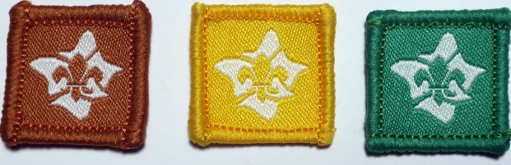
– Introduction to Section
– How the Section operates. Uniform, Patrols, hall, outdoors, programming, equipment, tents, backpacks, Section flag
– What is new in this section, compared to the previous section. Unit Council
– The Patrol System PL and new chum, team work, team planning, leadership
– Adventures, achievements, and our interests. What would you like to do ?
– Record keeping. Badges, activities log, standards, signing off badges.
– The Symbolic Framework World badges, section symbols, all the badge designs, images that make scouting stand out.
– The Unit/Section Code Good behaviour, assisting, leading, planning, Uniform.
--Committee, Annual & Term fees

Australian Scout Laws
BE RESPECTFUL
Be friendly and considerate
Care for others and the environment
BELIEVE IN MYSELF
Learn from my experiences
Face challenges with courage
DO WHAT IS RIGHT
Be trustworthy, honest and fair
use resources wisely

– Investiture date ….. as agreed
Give a copy of this to new chums/parents at the introduction
Sample posters for the Introduction talk
