DISCOVER ADVENTURE IN SCOUTS
Introduction to Scouting

We recommend that all new members come for 4-6 weeks to trial prior to deciding if they would like to join prior to outlaying fees and purchasing uniforms. It is also the time when we will review and complete the two introductory components to Scouting

What is Investiture?
Once the trial period has been completed, the youth member will decide to join the unit. They would be in full uniform and be prepared by the leader supporting their unit. The investiture of a youth member is a special moment for them, and for the Unit. The youth member is marking the start of their Scouting Journey. The Unit is gaining a valuable member that will be shaped and developed through the program journey that the Unit embarks on. The investiture ceremony is an occasion that helps to propel the youth member, their Patrol, and the Unit, towards lasting success, teamwork and adventure.
Investiture Components:
- Youth led and full of celebration and recognition of the youth member
- Includes the Promise and Law, Section Flag and all members present and the Scout sign is used
- The youth member will receive their scarf and initial badges for their uniform
including the world scout badge, Scouts Australia badge, district badge and group name tape.
- Important members or personal friends/family are invited at the request of the
youth member to celebrate starting their scouting journey.

The World Scout Organisation

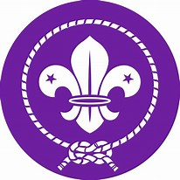
https://www.scout.org/
The World Scout Organisation Scouting is the largest educational youth movement and provides young people with opportunities to participate in programmes, events, activities and projects that contribute to their growth as active citizens.

The Story of Scouting
There are more than 40 million Scouts, young people and adults, male and female, in over 169 countries and territories. Some 500 million people have been Scouts, including prominent people in every field.
Early Beginnings All this began with 20 boys and an experimental camp in 1907. It was held during the first nine days of August in 1907 at Brownsea Island, England. The camp was a great success and proved to its organiser, Robert Baden-Powell, that his training and methods appealed to young people and really worked. In January 1908, Baden-Powell published the first edition of "Scouting for Boys". It was an immediate success and has since sold over 100 million copies. Robert Baden-Powell had only intended to provide a method of training boys, something that existing youth organisations such as the Boys' Brigade and YMCA could adopt. To his surprise, youngsters started to organise themselves into what was to become one of the largest voluntary youth movements in the world.
Expansion of the Movement The success of "Scouting for Boys" produced a Movement that quickly adopted the name of The Boy Scouts. By 1909 "Scouting for Boys" had been translated into five languages, and a Scout rally in London attracted more than 11,000 Scouts. As a result of Baden-Powell taking a holiday in South America, Chile was one of the first countries outside Britain to begin Scouting. In 1910 he visited Canada and the United States where it had already started. The coming of World War I in 1914 could have brought about the collapse of the Movement, but the training provided through the patrol system proved its worth. Patrol leaders took over when adult leaders volunteered for active service. Scouts contributed to the war effort in England in many ways; most notable perhaps were the Sea Scouts who took the place of regular coast-guardsmen, freeing them for service. The first World Scout Jamboree took place in 1920 with 8,000 participants, and proved that young people from different nations could come together to share common interests and ideals. Since that first World Jamboree at Olympia in London, there have been 21 others at different locations
The Early Scout Programme
Scouting began as a programme for boys 11 to 18 years of age. Yet almost immediately others also wanted to participate. The Girl Guides programme was started in 1910 by Baden-Powell who designated his sister Agnes to manage it. In 1915 Robert Baden-Powell became Chairman of the Girl Guides Association, and his wife Olave, whom he married in 1912, became the new Chief Guide in 1918. A Wolf Cub section was formed for younger boys. It used Rudyard Kipling's "Jungle Book", to provide an imaginative symbolic framework for activities. For older boys, a Rover Scout branch was formed.
100 years and beyond In 2007 the Movement celebrated its centenary - 100 years of Scouting. What started as a small camp on Brownsea Island is today a growing Movement in the world. Through its unique combination of adventure, education and fun, Scouting manages to continuously renew and adapt itself to a changing world and the different needs and interests of young people across the globe. In doing so it continues to be an inspiration for young people to become active local and global citizens, helping them in creating a better world.

Scouts Australia
https://scouts.com.au/
Scouts Australia provides boys and girls aged 5 to 25 with fun and challenging opportunities to grow through adventure. With 70,000 members,. What makes us unique is our diverse range of activities that develop skills in young people such as leadership, teamwork, problem solving and communication.
Today’s Scouts can take part in an extraordinary variety of outdoor activities, from ‘traditional Scouting skills’ such as camping and bushcraft, through to more extreme challenges such as abseiling, overnight hiking, rafting, canoeing, canyoning, snow activities, rock climbing, sailing… even flying!
The Scouts Australia Program also incorporates contemporary issues such as youth health, ‘responsible risk-taking’, vocational skills, and issues pertinent to Indigenous Australians. We offer an Award Scheme that encourages participation in the full range of activities available and provides recognition of individual achievement.
Scouts Australia is an accredited member of the
World Organisation of the Scout Movement (WOSM), which has over 40 million members in 169 National Scout Organisations around the world.

Uniform
Once you are sure your child wants to become a Scout, arrange to purchase a Shirt in an appropriate size. The following items will be supplied by the group when invested:
- World Scouting Badge * Australian Scouting badge
- District badges * Group name tape * Group Scarf * Woggle
- Uniform and Badge Layout see website https://central.scouts.com.au/

The Scout Promise
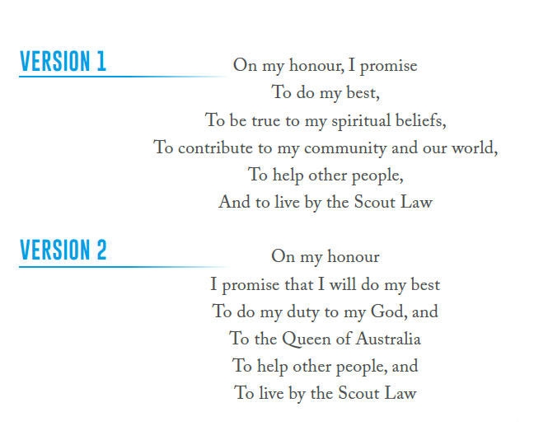
The Scout Law
Be Respectful
Be friendly, considerate
Care for others in the environment

Do what is Right
Be trustworthy, honest and fair
Use resources wisely

Believe in myself
Learn from my experiences
Face challenges with courage

Ceremonies and Flag (Opening and Closing Parade)
OPENING PARADE
Scouts form a semi-circle/horseshoe and come to alert.
- The flag is released, and the Scouts salute the flag

CLOSING PARADE
- Scouts form a semi-circle/horseshoe and come to alert.
- Two Scouts support by the leaders (optional) and the flag is lowered, and the scouts salute the flag as it is lowered
- Reflection or prayer (optional) by a Scout
- Duty patrol remain to fold the flag

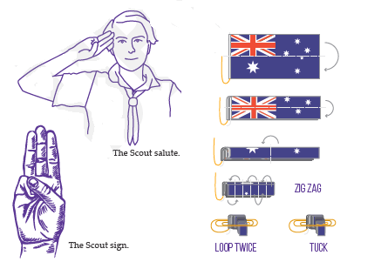

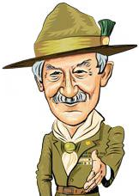
THE LEFT HANDSHAKE
Scouts from all over the world always greet other scouts with a warm left hand shake. The left hand being closest to the heart.
This tradition dates back to 1890 when Baden-Powell met African Warriors. The Warriors would hold their spears and shields in their left hand. As Lord Baden-Powell approached the warriors he would salute with his right hand and as a sign of bravery and respect they would lower their shields and shake with their left hand.
Impressed by this, Baden-Powell decided to introduce this into scouting.

THE PATROL SYSTEM
The Scout movement began through the natural formation of small teams of youth. Across all Sections, we call these ‘Patrols’. It is recognised that through Patrols, many of Scouting’s learning-by-doing experiences are encountered with peers. Working in Patrols provides opportunities to develop soft skills including leadership, teamwork and communication as well as building a sense of responsibility and belonging. Scouts working in Patrols is an important aspect of the Scout Method, providing a powerful learning environment, leadership opportunities, and the development of teamwork and communication skills.
A Patrol is a small team ideally:
- Consisting of 4-10 Scouts
- A range of ages and genders
- Led by a Patrol Leader (PL).
- Supported by 1 or 2 Assistant Patrol Leaders (APLs).

Scouts
- When our Patrol does activities and games a youth member helps lead
- We do activities that we are interested in
- We have a say in what activities our Patrol does
- We are supported by our Leaders.
- We get to help make decisions about what our Patrol does
- We help each other in our Patrol.
- Our Patrol uses the Plan> Do> Review> cycle regularly

Scout Method
All activities in Scouting are implemented using The Scout Method, a framework consisting of eight equally important elements. Whether it is through community involvement; nature and the outdoors; learning-by-doing; the patrol system; youth leading, adults supporting; personal progression, symbolic framework or the Promise and Law, young people are empowered to set goals and collaborate to achieve them.
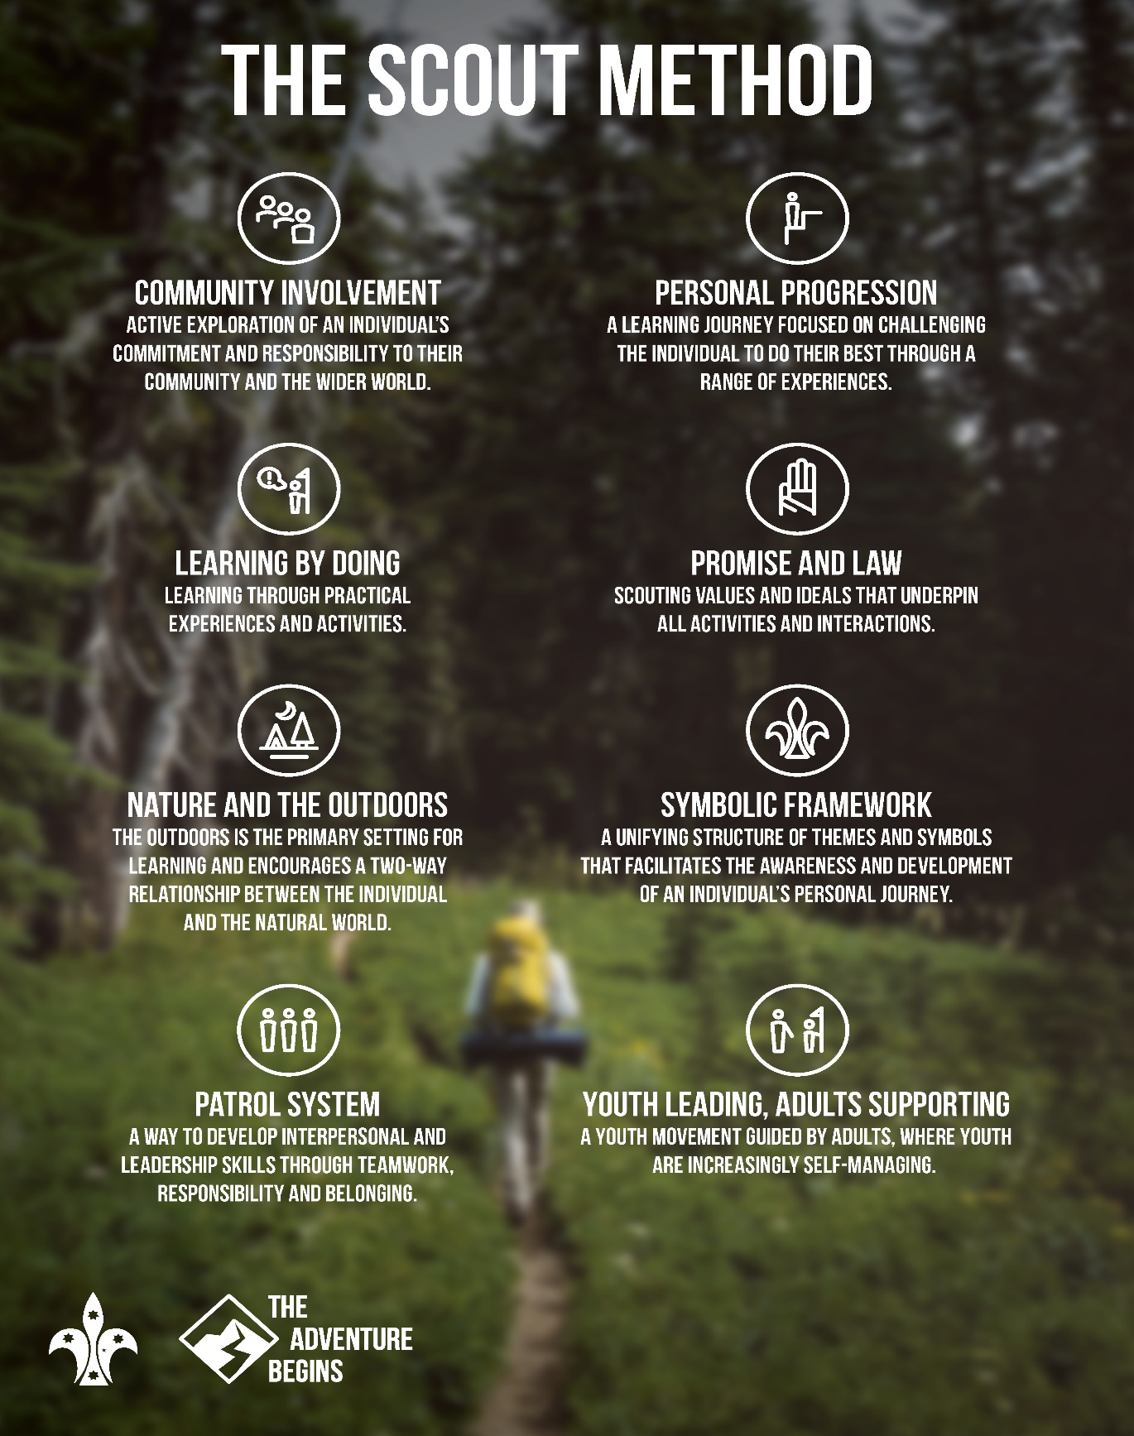

A Joey Unit Code of conduct (similar in all Units )

The basis of scouting is to make the Scout Promise and follow the Scout Law, however there needs to be a code developed to define what is acceptable and non-acceptable behaviour.
The Joey Scout section (and others) makes it’s own unit code. It is based upon specific behaviours that the Joey Scouts do not deem appropriate in their unit.
Reflecting on the Scout Promise and Law the Joey Scouts will be asked to contribute to the unit code and also suggest consequences for those not following the code. These rules and boundaries are set by the youth and enforced by the youth with adult support. This is to ensure that the youth feels empowered to feel safe at Scouts.
From time-to-time we also run anti-bullying programs such as Breaking the Cycle or reminding the youth of the Scout Promise and Law. Your youth member may come home and tell you that they are not permitted to return next week or other consequences set by the unit for not following the unit code. We appreciate parent support with this as without consequences to actions, the scout will not alter their behaviour and scout units affected by challenging behaviour and bullying often diminish in numbers at a fast rate. Bullying behaviours will not be accepted in our scout group and all scouts will be held accountable for their actions.

Joey Scouts will develop a code and this is updated regularly. Common items on the code over the years have been:
- No bear hugs
- Please ask my permission before you hug me
- No hitting or slapping
- If I say no or don’t I mean it and you must stop
- Please listen if I ask you not to chase me anymore
- No pulling my arms
- No hurting yourself or Quenda will get you to fill in the incident form (this is my favourite)

All Joey Scouts can add to the unit code at any time and add any behaviours that they are finding inappropriate and would like to stop.
Joey, Cub, Scout, Venturer, Rover Unit Councils (senior members & a Leader)
As a youth leading, adult supporting organisation, the Scout leaders rely on the Scouts thinking of activities that they would like to do on nights and weekends. We run a unit council regularly to get the youth to think of ideas for programs and activities in the 4 Challenge Areas (Creative, Community, Outdoors and Personal Growth). You should encourage your Scout to think of ideas of activities that they could assist and lead including games, special interest badge activities, hikes, camps etc.
Weekly activities for Milestone badges include 4 areas.
Outdoors Creative Personal Growth Community

Plan > Do > Review
Plan>Do>Review> means better activities, more fun, and your Unit getting to choose its own adventures, and to be involved in organising them. Plan>Do>Review> helps ensure everyone has a fun and adventurous time in Scouting and gets to learn something new.
Plan>
• Decide what you’re going to do
• Decide who’s going to lead and who’s going to do other jobs
• Work out what is needed
• Find out what skills you need
• Make some plans
• Use experts, like your Leaders, to help you

Do>
• Ensure everyone is involved
• Test out new skills
• Follow your plan, but it’s ok to change it if you need to
• Have fun
• Work as a team

Review>
• At the end of an activity, take a moment to review it
• Ask good questions of each other
• What did you hear, see, notice and enjoy about your adventure?
• What didn’t go to plan?
• What would you do differently next time?
• Talk about your achievements
• Thank everyone who participated

Plan> the program
• Get the whole Unit to have their say about how the program cycle went. Share your ideas in small teams and then nominate a team member to report back to the whole Unit.
• Get the whole Unit to come up with ideas for the next term. It might be games, activities, camps, badges to complete, Unit visits, inter-sectional visits and more. You could choose ideas around a theme like ‘adventures’.
» Your Leaders might provide some ideas and help expand on your ideas.
» Use the Plan>Do>Review> cards to help you.
» Do this in small teams and have a competition to see which team comes up with the most ideas.
» Then select or vote on the best ideas - try to make sure you spread your ideas across the Challenge Areas!
» Make sure everyone is excited about what’s been planned! • Your Leaders will let you know the final plans and confirm who has what responsibilities. This might happen with a small group of older Joey Scouts.

Plan> the meeting or adventure
• Have a go at planning and running a game or activity. Don’t worry if it doesn’t work out, your Leaders are there to help you.
» Who will run a game or activity?
» What will they do and how?
» What gear is required?
» What help is needed?
Do>
• Run your game or activity
» Practise at home beforehand
» Have all the gear ready
» Have fun doing it
» Follow your plan
• Enjoy the activities you helped to create

Review>
• Just before the end of the meeting, sit down and have a quick chat about how things went (maybe choose 2 questions to discuss)
» What did you enjoy?
» What didn’t you enjoy?
» “I really liked learning about…”
» “Something that I can do now that I couldn’t do before is…” “I think next time we should…” » Who did a good job? » What should we do again? » You might use

SPICES
The Scout program develops youth of all ages in the six SPICES areas. Those areas are Social, Physical, Intellectual, Character, Emotional, and Spiritual development.
The scouts use the SPICES to review programs to make sure that the program is balanced and covers all of the SPICES.
SPICES
Social development refers to belonging to a group, one’s relationships with others, and understanding differences between people in small groups of peers, as well issues of diversity and inclusion in larger communities.
Physical development refers to one’s understanding of their body, including active care for health, wellbeing, and the pursuit of physical skills and fitness

Intellectual development refers to one’s ability to think, plan, innovate, review and be creative, applying information, knowledge, and skills in new and different circumstances.

Character development refers to the pursuit of personal best. It includes positive attitude, responsibility, respect, and making an effort beyond what benefits the self. It encapsulates personal growth in the five other SPICES.
Emotional development refers to the need for understanding of one’s own emotions and the emotions of others. It includes awareness of how a person is feeling, expressing emotions in a positive manner, as well as respecting and supporting the emotional needs of others.

Spiritual development is an area which many find challenging to create rich developmental programs. The Internal Compass offers a framework for youth and adults to understand spirituality and Spiritual Development in Scouting, and to create interesting programs that encourage personal growth in this area.
Before looking at the Internal Compass itself, it’s important to understand spirituality. While there are many different definitions and understandings, Scouts Australia defines spirituality in the following way:
“Spirituality refers to the feelings or beliefs of a person regarding their purpose in life, connection to others and place in the world around them. These spiritual feelings or beliefs may change as a person develops and guide their actions throughout their life.”Scouts Australia Policy and Rules
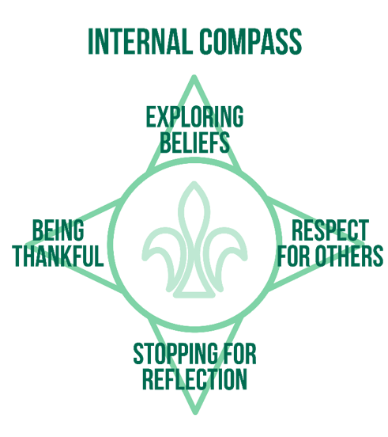
Program Essentials

Joey Scout Milestone badges 1, 2 & 3 or similar for Cubs, Scouts, Venturers, Rovers
Program Essentials are divided into a series of Milestones within each Section. Each Milestone badge should take approximately 6-12 months, and recognises active participation in the program, and personal development that has occurred during that time. It should not be viewed as something extra to work on, but rather represents regular and active participation.

There are two key elements to each Milestone in Program Essentials:
- Participating, Assisting or Leading
- Personal reflection at the completion of each Milestone.
This reflection should include:
  - An assessment of how you developed through SPICES, and the utilisation of the Scout Method;
  - What the Scout actively did to make inclusion of others part of the program; and
  - Actions that were taken to incorporate elements of the Australian Scout Promise and Law.

It is expected that all Scouts will achieve the Program Essentials Milestones, regardless of their interest in exploring the rest of the Achievement Pathways elements. Program Essentials should always be tailored to individuals, with the individual demonstrating their personal development, providing their reflections, and exhibiting their personal best during participating, assisting and leading. For a more in-depth understand of participating, assisting and leading in the Section, refer to the youth member digital system Terrain, the Section Guide, Record Book or Program Handbook..

Outdoor Adventure Skills OAS 9 groups

Outdoor Adventure Skills (OAS) are the link between adventurous activities and the youth program. They enable youth members of all ages to access the basic skills for a range of activities, and progress through to high skill levels across nine broad activity areas. The core skills areas epitomise what is often viewed as ‘key Scouting skills’ and are encouraged for all Sections, whilst the specialist skill areas offer diversity of choice.

The early stages of all Outdoor Adventure Skills are for those who want to try out the activity and establish foundational skills which is what our focus will be in Joey Scouts.

The higher stages are geared towards the Scout who wishes to explore these pursuits in greater depth than what is provided for in the core program. Where a relevant Unit of Competency exists in the Vocational Education and Training (VET) package, Stages 5 - 9 have been written such that Scouts are showing skills and could undertake simple mapping to gain the formal Units of Competency through Scouts Australia Institute of Training (SAIT).
The Outdoor Adventure Skills are intended to be achieved by individual Scouts; although as part of a balanced program and the undertaking of Challenge Areas, a Patrol or entire Unit may undertake some activities and skill development. On any given adventure, there may be Scouts undertaking a variety of different stages in the same group, each learning and displaying the skills that they are up to, at their own pace.

The Outdoor Adventure Skills carry through all Sections.
The lowest stages have been written with the younger youth members in mind, however keen or skilled Scouts in these Sections can progress ahead. There are no age restrictions on the achievement of these stages. However, due to the time and skill levels required to be shown in the middle and higher stages, it is unlikely that Scouts in the youngest Sections will be able to achieve too many stages beyond their peers and thus 'run out' of challenges to pursue in later Sections.
Community standards and legislative requirements may impact on the possible outcomes when youth members seek recognition of their Outdoor Adventure Skills achievements to obtain Units of Competency

Special Interest Badges SIA
Scouts can complete special interest badges in the areas of:
- Adventure and Sport
- Arts and Literature
- Creating a better world
- Environment
- Growth and Development
- STEM and Innovation

We will be using planning tools to assist the Scouts with these activities but parent assistance with this and gathering information and evidence for these badges may be required.
Other resources at
https://sydneynorthregionscoutsresources.weebly.com/

Record Keeping = Books and On Line in Terrain
We will arrange times for Scouts to demonstrate for their badges. We may need to allocate time to meet before or after a night or on separate nights to complete some of this work.

Thanks to Amanda & OZ leaders

Achievement Pathways
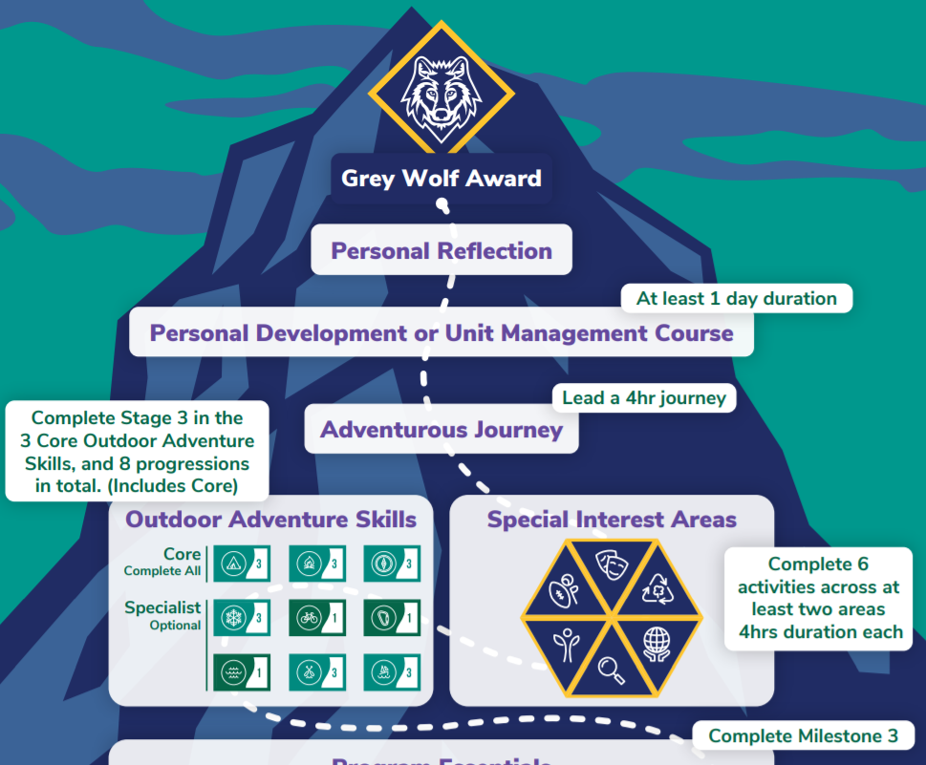
Milestone year 1 Milestone year 2 Milestone year 3

Introduction to the Section, Unit or Cub Pack. 