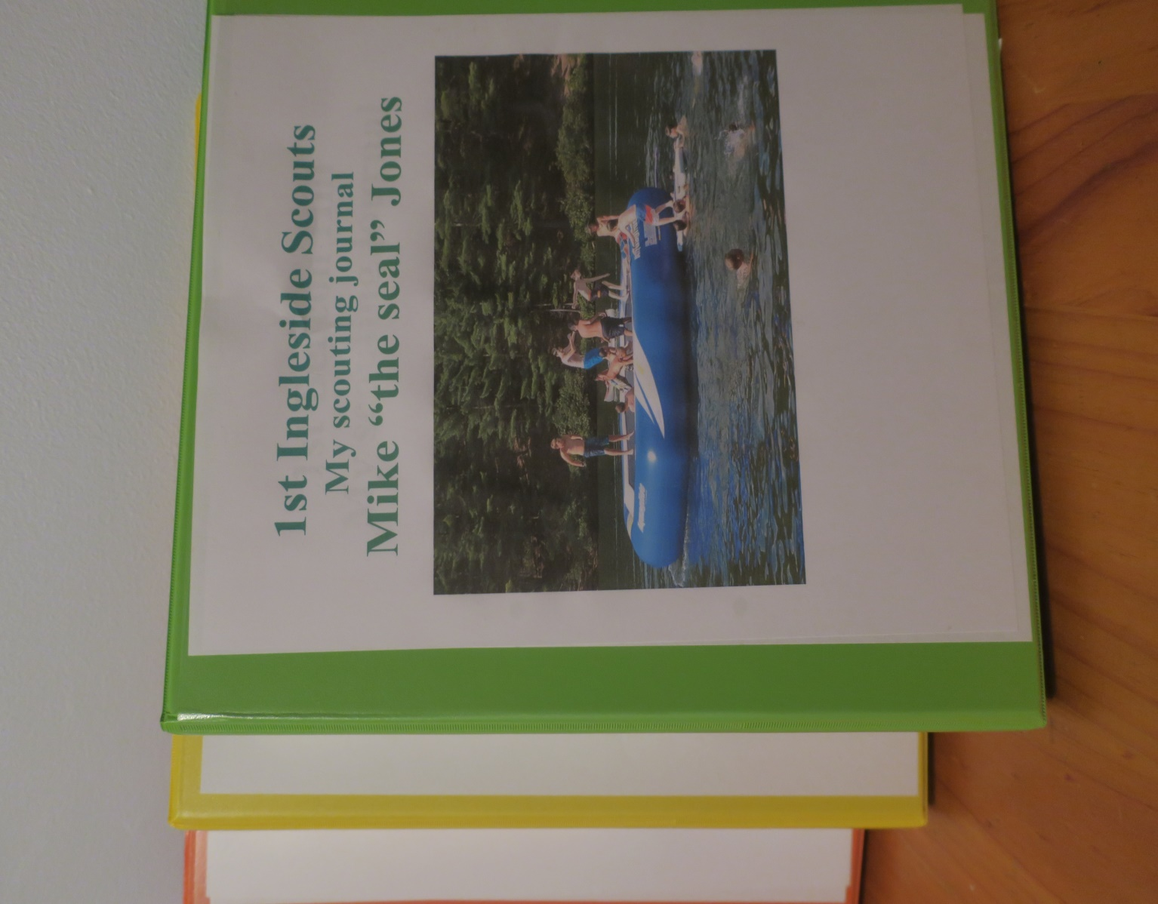
A4 two ring binder for all their adventures.
Different colours for the sections
Files can be found on the resources site at https://sydneynorthregionscoutsresources.weebly.com/
And on the New Youth Program resources site
https://pr.scouts.com.au/

