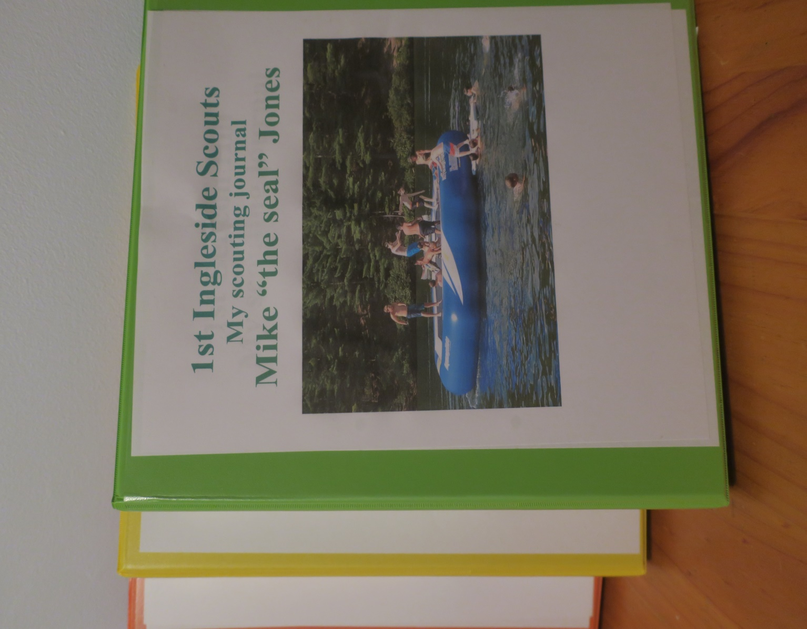

A4 two ring binder for all their adventures. Different colours for the sections

Files can be found on the resources site at <https://sydneynorthregionscoutsresources.weebly.com/>

And on the New Youth Program resources site

<https://pr.scouts.com.au/>

Sample pages below. Only include those pages that a scout absolutely needs. Add more as they understand more. Use in conjunction Online apps & other record keeping books.

1st Ingleside Cubs Review this regularly during the term

Program Term 3 Stick this on the fridge !

**MEETINGS -** Monday Nights 6.30pm to 8pm at the hall *unless otherwise listed below*

New ? Call or just turn up and introduce yourselves and bring a friend

**Location. Ingleside Reserve Woods ave Ingleside**

**Contact** Peter at [akela@inglesidecubs.com.au](mailto:akela@inglesidecubs.com.au) 0405 623 978

|  |  |  |  |  |  |
| --- | --- | --- | --- | --- | --- |
| **Date** | Location, Activity, Times  Milestone badge challenge = Community, Creative, Outdoors or Personal Growth) | Badges. Milestone challenge.Special Interest or Outdoor Activity | **Duty**  **Patrol** | **Youth Assist & Lead** | **Leader & parent helpers** |
| 22 July Monday | Review, planning and finalization of program night from the suggestions. | Program review |  |  | Youth & Leaders |
| 29 July Monday | Scavenger hunt night.  Photo’s or drawing throughout the hunt.  Program review & record your badges | Personnal growth | Dingos | Borne lead, Benny | Bear |
| 5 August Monday | Morning scarf up at school. ?  For World Scout dayCampfire and skits. | Community | School & scout hall  Cubs |  | Akela & Dave Jones |
| 12 August  Monday | Orienteering. at Curl Curl  1st Aid. What to do in the bush dangers. | Outdoors | panther | Alex assist | Greeny |
| 19 August Monday | Rock House climbing  permission needed | Outdoors | Brookvale |  | Akela |
| 24&25 Aug Sat & Sun | Camp & campfire, Ingleside scout camp.  Unit Council | OAS  Outdoors  Camping |  |  | Jim  Greeny/  Bear |
| 26 August Monday | Craft. Gifts & prep for Father’s Day  Program review & record your badges | Creative | Redbacks | Alex, lead Perry | Akela & sally Pike |
| 2 Sept Monday | Father’s Day. cooking. Games.  Teach dad a knot? Present for dad. | Personal Growth | Bears | Cam lead David | Barloo |
| 9 Sept Monday | Ninja warrior night. Cargo net, Crawl, Tyres? Term 4 activities ??? | Outdoors | Dingos | Sally assist | Akela |

|  |  |  |
| --- | --- | --- |
| **NAME:** | **Cub Scout** | **Joined Section date:** |
| **PL / patrol** | **DOB** | **11th birthday date:** |

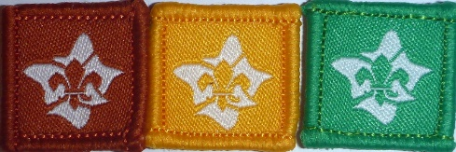

|  |
| --- |
| **INTRODUCTION TO SCOUTING** discussion with PL / Leaderdate: |
| **INTRODUCTION TO THE SECTION** discussionwith PL **/** Leaderdate: |

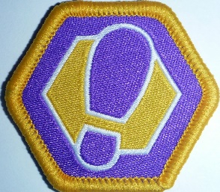

**Milestone Badge 1 Participation Assist Lead**

|  |  |  |  |  |  |  |  |  |  |  |  |  |  |  |
| --- | --- | --- | --- | --- | --- | --- | --- | --- | --- | --- | --- | --- | --- | --- |
| Nights/activities | 1 | 2 | 3 | 4 | 5 | 6 | **1** | **2** |  |  | **1** |  |  |  |
| **Community** |  |  |  |  |  |  |  |  |  |  |  |  |  |  |
| **Creative** |  |  |  |  |  |  |  |  |  |  |  |  |  |  |
| **Outdoors** |  |  |  |  |  |  |  |  |  |  |  |  |  |  |
| **Personal Growth** |  |  |  |  |  |  |  |  |  |  |  |  |  |  |
| Awarded |  |  |  |  |  |  |  |  |  |  |  |  |  |  |

* **Check on your Term program for what parts have been done**

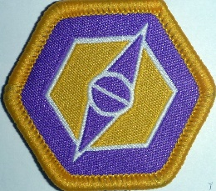

**Milestone Badge 2 Participation Assist Lead**

|  |  |  |  |  |  |  |  |  |  |  |  |  |  |  |
| --- | --- | --- | --- | --- | --- | --- | --- | --- | --- | --- | --- | --- | --- | --- |
| Nights/activities | 1 | 2 | 3 | 4 | 5 |  | **1** | **2** | **3** |  | **1** | **2** |  |  |
| **Community** |  |  |  |  |  |  |  |  |  |  |  |  |  |  |
| **Creative** |  |  |  |  |  |  |  |  |  |  |  |  |  |  |
| **Outdoors** |  |  |  |  |  |  |  |  |  |  |  |  |  |  |
| **Personal Growth** |  |  |  |  |  |  |  |  |  |  |  |  |  |  |
| Awarded |  |  |  |  |  |  |  |  |  |  |  |  |  |  |
|  |  |  |  |  |  |  |  |  |  |  |  |  |  |  |

**Milestone Badge 3 Participation Assist Lead**

|  |  |  |  |  |  |  |  |  |  |  |  |  |  |  |
| --- | --- | --- | --- | --- | --- | --- | --- | --- | --- | --- | --- | --- | --- | --- |
| Nights/activities | 1 | 2 | 3 | 4 |  |  | **1** | **2** | **3** | **4** | **1** | **2** | **3** | **4** |
| **Community** |  |  |  |  |  |  |  |  |  |  |  |  |  |  |
| **Creative** |  |  |  |  |  |  |  |  |  |  |  |  |  |  |
| **Outdoors** |  |  |  |  |  |  |  |  |  |  |  |  |  |  |
| **Personal Growth** |  |  |  |  |  |  |  |  |  |  |  |  |  |  |
| Awarded |  |  |  |  |  |  |  |  |  |  |  |  |  |  |

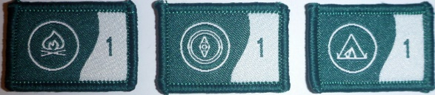

|  |  |  |  |  |
| --- | --- | --- | --- | --- |
| **OUTDOOR ADVENTURE SKILLS** OAS 3 Core skills **\***  **Check your LOG & Online** | | | | |
| **BADGE** | **STAGE 1** | **STAGE 2** | **STAGE 3** | **STAGE 4** |
| **BUSHCRAFT** |  |  |  |  |
| **BUSHWALKING** |  |  |  |  |
| **CAMPING** |  |  |  |  |

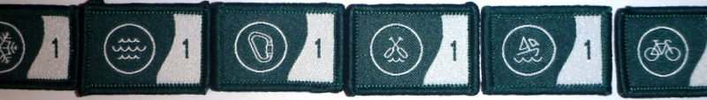

|  |  |  |  |  |
| --- | --- | --- | --- | --- |
| **OUTDOOR ADVENTURE SKILLS** OAS 6 other skills  **\***  **Check your LOG & Online** | | | | |
| **BADGE** | **STAGE 1** | **STAGE 2** | **STAGE 3** | **STAGE 4** |
| **Alpine- skiing** |  |  |  |  |
| **Aquatics, swimmingEtc** |  |  |  |  |
| **Boating- sailing** |  |  |  |  |
| **Paddling, canoeing** |  |  |  |  |
| **Cycling** |  |  |  |  |
| **Vertical, climbing, cave** |  |  |  |  |

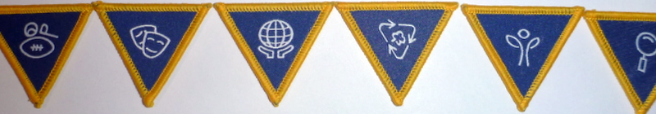

|  |  |  |  |  |  |  |
| --- | --- | --- | --- | --- | --- | --- |
| **SPECIAL INTEREST AREA** BADGES **SIA * Your choice, design your challenge – 4 hours each** | | | | | | |
| **Adventure & Sport** |  |  |  |  |  |  |
| **Arts & Literature** |  |  |  |  |  |  |
| **Creating a Better World** |  |  |  |  |  |  |
| **Environment** |  |  |  |  |  |  |
| **Growth & Development** |  |  |  |  |  |  |
| **STEM & Innovation** |  |  |  |  |  |  |

See badges on separate sheet  sample

|  |  |  |  |
| --- | --- | --- | --- |
| **ADDITIONAL AWARDS** see Record book | | | |
| **LANDCARE**  Participate in 3 National accredited environment events. See book | Event 1: _______________  Time Spent : ___________  Date: ______ _________ | Event 2: _________________  Time Spent : _____________  Date: ______ _________ | Event 3: _________________  Time Spent : _____________  Date: ______ _________ |
| **LANGUAGE EMBLEM**  see Record book | Have a simple conversation for 10 minutes | Write a letter of at least 100 words | Translate in your own time and with the help of a dictionary an easy passage from a book or magazine. |
| **MESSENGERS of PEACE** | Learn about the Messengers of Peace initiative in a Cub Scout meeting or online.  Date Completed- | Participate in a community involvement action organised together with your Patrol.  Date Completed- | Share your actions online with the help of an adult at scout.org/messenger of peace  Date Completed- |
| **THEIR SERVICE –OUR HERITAGE**  This award is achieved annually commencing 25th April | Participate in 3 Activities  **Suggestions are:**  ANZAC Day | Remembrance Day  Invite Veteran to a meeting or visit Veterans Home | Maintain local Memorial  Visit Tomb of the Unknown Solder |
| **WORLD ENVIRONMENT BADGE** | Discuss with leaders | See the Record book |  |
| **CAMPER AWARD** | Depicts total number of nights spent under canvas | Increments as 10, 25, 50, 75 & 100 nights | See LOG & Terrain records |
| **WALKABOUT AWARD** | Depicts total number of kilometres covered on Scouting Activities | Increments as 10, 50, 100, 150, 200, 300, 400 & 500 kilometres | See LOG & Terrain records |

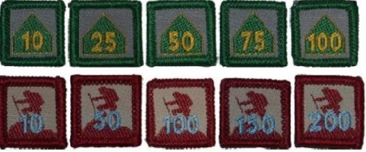



|  |  |  |
| --- | --- | --- |
| **PEAK AWARD GREY WOLF AWARD Dates** | | |
| **Milestone 3 badge** |  |  |
| **Outdoor Adventure Skills**  8 stages completed whilst in Cubs | | |
| Bushcraft Stage 3 minimum. If new to Cubs then 3 Core by | |  |
| Bushwalking Stage 3 min 3 Stages = 9 | |  |
| Camping Stage 3 min | |  |
| Others: | |  |
|  | |  |
| **6 Special Interest Areas**. Minimum choice of 2 from the 6 areas. 4 hrs each | |  |
| 1. | |  |
| 2. | |  |
| 3. | |  |
| 4. | |  |
| 5 | |  |
| 6. | |  |
| **Leadership Course** at least 1 day | |  |
| **Adventurous Journey P**lan & lead a journey of at least 4 hours (max 2 cubs planning) | |  |
| **Personal Reflection** review of what has been achieved | |  |
| **Unit Council review** | |  |

|  |  |  |  |  |
| --- | --- | --- | --- | --- |
| **Activity Log** | |  | Name________________________ | |
|  |  |  |  |  |
| Dates | Bushwalk, camp, canoe, sail, bike, Ski, cave, District, Region etc | klms, camp days, etc | Location,  Grade. | What did you do, achieve, who went along, weather, equip,  Your role in the activity ?.  Participant, assist, lead, guide.  Who were the assessors ? |
|  |  |  |  |  |
|  |  |  |  |  |
|  |  |  |  |  |
|  |  |  |  |  |
|  |  |  |  |  |
|  |  |  |  |  |
|  |  |  |  |  |
|  |  |  |  |  |
|  |  |  |  |  |
|  |  |  |  |  |

Print 2 sided For cycling, canoeing etc divide the distance by 2-3 to get approx. klms for Walkabout badge

Then pages from Outdoor Adventurous Skills from Excel spreadsheet or Online app.

|  |  |
| --- | --- |
| Bushcraft Stage 1 Sample | |
| **Introductory Skills** | |
| **Plan>** |  |
| |  | | --- | |  | | I know why it is important to stick to trails when outdoors. |
|  | I can explain the buddy system. |
|  | I know to stop when I get lost on activities. |
|  | I know my address and location in an emergency. |
|  | I know three reasons for having a shelter when sleeping outdoors. |
| **Do>** |  |
| |  | | --- | |  | | I can strike a match. |
|  | I can collect sticks for preparing a campfire. |
|  | I can be safe around a campfire. |
|  | I have participated in a game that required basic navigational skills. |
|  | I can hang a clothesline at camp with a clove hitch or other knot. |
|  | I know how to correctly pack ropes away. |
|  | I know what is in a dilly bag / mess kit and can keep it clean at camp. |
| **Review>** |  |
| |  | | --- | |  | | I can talk about what I enjoyed, learnt, or improved upon, by playing a navigational game. |
|  | Unit Council Sign off |
|  | date awarded |

|  |  |
| --- | --- |
| Suggested topics for Special Interests | Can be with the Unit, patrol or individual. Plan – Do - Review something that you are interested in. |
| Art & Design | Athlete |
| Entertainer | Collector |
| Handcraft | Cooking |
| Handyworker | Pets |
| Literature | Sports |
| Masks & Sculpture | Citizenship etc etc |
| Other ideas for later on |  |
|  |  |

My Special Interest Badge planner 

**Plan Do Review**

|  |
| --- |
| Name Date Finish by |
| From the six SIA badges below, my choice is |
| My subject for the badge is |
| My goal 1 |
| My goal 2 |
| My goal 3 |
| My goal 4 |
| Individual ? or Patrol project ? Who else is doing the badge with you? |
| I am being supported by a PL, Subject matter expert, Mentor or Leader.  **who is-** |
| Review. What did you learn from doing this badge ? |
| Discuss your results with the Unit |

**Arts** & Literature Environment Growth & Develop Create Better World Stem Adventure & Sport

     

**Additional Badges For details of these badges** either go to Scout Central then Scout Shop & Sign In, click Badges (Joeys to Leaders) & click on the badge & then click on the details **OR** go to your Record Book (new or old).  **Badges are not for all Sections**

|  |  |  |  |
| --- | --- | --- | --- |
| Landcare | Waterwise | Local History | Faith Awareness |
|  |  |  |  |
| World Scout Environment | Language Emblem | Messengers of Peace | Faith Awareness |
|  |  |  |  |
| Their Service, Our Heritage | State Emergency Services | Abchor Badge | Amateur Radio Operator |
|  |  |  |  |
| Scouts of the World | Youth helper | Surf Life Saving | First Aid |
|  |  | Surf Life Saving Australia (@SLSAustralia) | Twitter |  |

**Milestone Challenges** 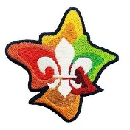

Some ideas

|  |  |  |  |
| --- | --- | --- | --- |
| **Community** | **Creative** | **Outdoors** | **Personal Growth** |
| Getting out in the community Engagement Involvement Projects & Partnerships  Visits Volunteering Diversity & Inclusion Environment Active citizenship | Expression Arts  Making Creating Inventing Designing Planning | Environment Camping  Time in nature Water activities Adventurous activities Journeys | Health & Wellbeing Resilience Mental health Beliefs & Values  Social justice Skills  Interests |
| Local  National International Supporting Knowledge Service | Unusual  New  Colourful  Bold Innovative Investigative | Fast  High  Wide  Slow  Deep  Safe | Individual Healthy Growing Believing Commitment Understanding New skills |
| **Inclusive** | **Challenging** | **Fun** | **Adventurous** |

|  |
| --- |
|  |
| **Australian Scout Promise** |
| On my honour, |
| I promise to do my best, |
| To be true to my spiritual beliefs, |
| To contribute to my community |
| and our world, |
| To help other people |
| And to live by the Scout Law. |
|  |
|  |
| **Australian Scout Laws** |
| BE RESPECTFUL |
| Be friendly and considerate |
| Care for others and the environment |
| BELIEVE IN MYSELF |
| Learn from my experiences |
| Face challenges with courage |
| DO WHAT IS RIGHT |
| Be trustworthy, honest and fair |
| use resources wisely |

Unit Code of Conduct

Ok , you get the idea. Good luck