NAME: | Cub Scout | Joined Section date:
PL / patrol | DOB | 11th birthday date:
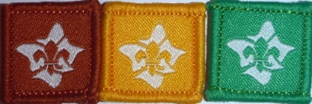
INTRODUCTION TO SCOUTING discussion with PL / Leader date:
INTRODUCTION TO THE SECTION discussion with PL / Leader date:
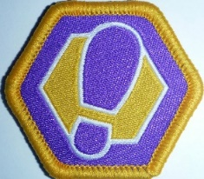
Milestone Badge 1 24 Participations 2 Assists 1 Lead
Nights/activities | 1 | 2 | 3 | 4 | 5 | 6 | 1 | 2 |  |  | 1
Community
Creative
Outdoors
Personal Growth
Awarded
- Check on your Term program for what parts have been done
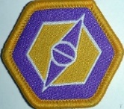
Milestone Badge 2 20 Participations 3 Assists 2 Leads
Nights/activities | 1 | 2 | 3 | 4 | 5 |  | 1 | 2 | 3 |  | 1 | 2
Community
Creative
Outdoors
Personal Growth
Awarded
Milestone Badge 3 16 Participations 4 Assists 4 Leads
Nights/activities | 1 | 2 | 3 | 4 |  |  | 1 | 2 | 3 | 4 | 1 | 2 | 3 | 4
Community
Creative
Outdoors
Personal Growth
Awarded
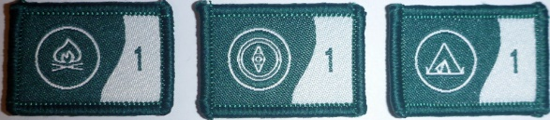
OUTDOOR ADVENTURE SKILLS OAS 3 Core skills * Check your LOG & Online
BADGE | STAGE 1 | STAGE 2 | STAGE 3 | STAGE 4
BUSHCRAFT
BUSHWALKING
CAMPING

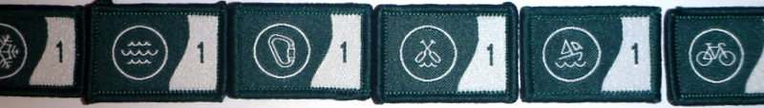
OUTDOOR ADVENTURE SKILLS OAS 6 other skills * Check your LOG & Online
BADGE | STAGE 1 | STAGE 2 | STAGE 3 | STAGE 4
Alpine- skiing
Aquatics, swimmingEtc
Boating- sailing
Paddling, canoeing
Cycling
Vertical, climbing, cave

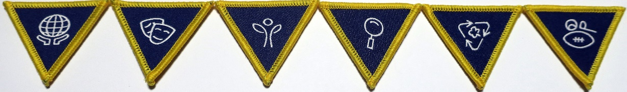
SPECIAL INTEREST AREA BADGES SIA * Your choice, design your challenge – 4 hours each
Adventure & Sport
Arts & Literature
Creating a Better World
Environment
Growth & Development
STEM & Innovation

See badges on separate sheet sample
ADDITIONAL AWARDS see Record book
LANDCARE  Participate in 3 National accredited environment events. See book | Event 1: _______________  Time Spent : ___________  Date: ______ _________ | Event 2: _________________  Time Spent : _____________  Date: ______ _________ | Event 3: _________________  Time Spent : _____________  Date: ______ _________
LANGUAGE EMBLEM  see Record book | Have a simple conversation for 10 minutes | Write a letter of at least 100 words | Translate in your own time and with the help of a dictionary an easy passage from a book or magazine.
MESSENGERS of PEACE | Learn about the Messengers of Peace initiative in a Cub Scout meeting or online.  Date Completed- | Participate in a community involvement action organised together with your Patrol.  Date Completed- | Share your actions online with the help of an adult at scout.org/messenger of peace  Date Completed-
THEIR SERVICE –OUR HERITAGE  This award is achieved annually commencing 25th April | Participate in 3 Activities  Suggestions are:  ANZAC Day | Remembrance Day  Invite Veteran to a meeting or visit Veterans Home | Maintain local Memorial  Visit Tomb of the Unknown Solder
WORLD ENVIRONMENT BADGE | Discuss with leaders | See the Record book
CAMPER AWARD | Depicts total number of nights spent under canvas | Increments as 10, 25, 50, 75 & 100 nights | See LOG & Terrain records
WALKABOUT AWARD | Depicts total number of kilometres covered on Scouting Activities | Increments as 10, 50, 100, 150, 200, 300, 400 & 500 kilometres | See LOG & Terrain records
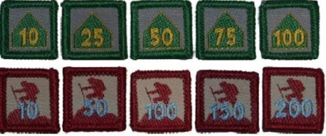

PEAK AWARD GREY WOLF AWARD Dates
Milestone 3 badge
Outdoor Adventure Skills 8 stages completed whilst in Cubs
Bushcraft Stage 3 minimum. If new to Cubs then 3 Core by
Bushwalking Stage 3 min 3 Stages = 9
Camping Stage 3 min
Others:
6 Special Interest Areas. Minimum choice of 2 from the 6 areas. 4 hrs each
1.
2.
3.
4.
5
6.
Leadership Course at least 1 day
Adventurous Journey Plan & lead a journey of at least 4 hours (max 2 cubs planning)
Personal Reflection review of what has been achieved
Unit Council review

Personal Reflection – the Cub Scout will reflect on their journey through the Cub Scout Section with a Leader and other Cub Scouts. The Personal Reflection can be ‘documented’ using record books, maps, photographs or videos or there may be very little ‘documentation’ and the Cub Scout tells a story about their experience. This is an opportunity to recall the adventures the Cub Scout has experienced, to share some of the highlights and challenges, and to reflect on their development in the six SPICES areas. However it is done, it is up to the Cub Scout to do their best. From Cubs Victoria 1.9.20

