NAME: | Joey Scouts | Joined Section date:
PL/patrol | DOB | 8th birthday date:
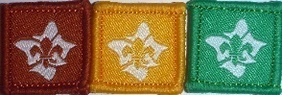
INTRODUCTION TO SCOUTING discussion with PL / Leader date:
INTRODUCTION TO THE SECTION discussion with PL / Leader date:
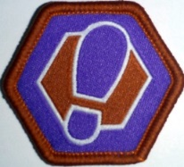
Milestone Badge 1 24 Participations 2 Assists 1 Lead
Nights/activities | 1 | 2 | 3 | 4 | 5 | 6 | 1 | 2 |  |  | 1
Community
Creative
Outdoors
Personal Growth
Awarded
- Check on your Term program for what parts have been done
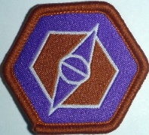
Milestone Badge 2 20 Participations 3 Assists 2 Leads
Nights/activities | 1 | 2 | 3 | 4 | 5 |  | 1 | 2 | 3 |  | 1 | 2
Community
Creative
Outdoors
Personal Growth
Awarded
Milestone Badge 3 16 Participations 4 Assists 4 Leads
Nights/activities | 1 | 2 | 3 | 4 |  |  | 1 | 2 | 3 | 4 | 1 | 2 | 3 | 4
Community
Creative
Outdoors
Personal Growth
Awarded

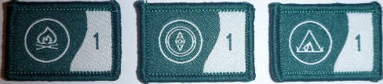
OUTDOOR ADVENTURE SKILLS OAS 3 Core skills * Check your LOG & Online
BADGE | STAGE 1 | STAGE 2
BUSHCRAFT
BUSHWALKING
CAMPING

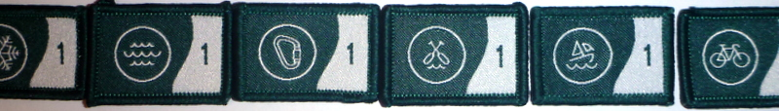
OUTDOOR ADVENTURE SKILLS OAS 6 other skills * Check your LOG & Online
BADGE | STAGE 1 | STAGE 2
Alpine- skiing
Aquatics, swimmingEtc
Boating- sailing
Paddling, canoeing
Cycling
Vertical, climbing, cave

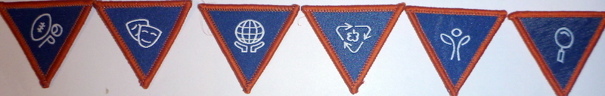
SPECIAL INTEREST AREA BADGES SIA * Your choice, design your challenge – 2 hours each

Adventure & Sport | Arts & Literature | Creating a Better World | Environment | Growth & Development | STEM & Innovation

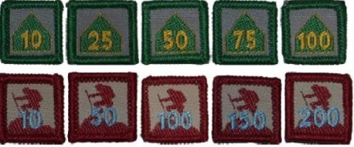
CAMPER AWARD  Update log | Depicts total number of nights spent under canvas | Increments as 10, 25, 50, 75 & 100 nights | See LOG & Terrain records
WALKABOUT AWARD  Update log | Depicts total number of kilometres covered on Scouting Activities | Increments as 10, 50, 100, 150, 200, 300, 400 & 500 kilometres | See LOG & Terrain records

See badges on separate sheet sample
ADDITIONAL AWARDS see record book
LANDCARE  Participate in 3 National accredited environment events. See book | Event 1: _______________  Time Spent : ___________  Date: ______ _________ | Event 2: _________________  Time Spent : _____________  Date: ______ _________ | Event 3: _________________  Time Spent : _____________  Date: ______ _________
MESSENGERS of PEACE  See book | Learn about the Messengers of Peace initiative in a Joey Scout meeting or online.  Date Completed: | Participate in a community involvement action organised together with your Patrol.  Date Completed: | Share your actions online with the help of an adult at scout.org/messenger of peace  Date Completed:
THEIR SERVICE –OUR HERITAGE  This award is achieved annually commencing 25th April | Participate in 3 Activities  Suggestions are:  ANZAC Day | Remembrance Day  Invite Veteran to a meeting or visit Veterans Home | Maintain local Memorial  Visit Tomb of the Unknown Solder
WORLD ENVIRONMENT BADGE  See book: A. Explore & B. Take action | Discuss with leaders and patrol

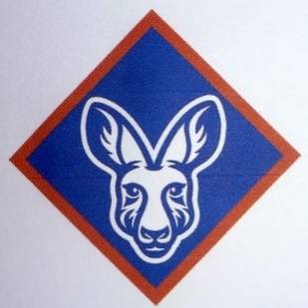
PEAK AWARD JOEY SCOUT CHALLENGE AWARD Dates
Milestone 3 Badge
Outdoor Adventure Skills. Minimum of Stage 1 in each of the 3 Core skills
Bushcraft Stage 1 (minimum)
Bushwalking Stage 1 “
Camping Stage 1 “
Others:
6 Special Interest Areas Minimum choice of 2 from the 6 areas - 2 hours each
1.
2.
3.
4.
5
6.
Adventurous Journey participate in a journey of at least 3 hours
Personal Reflection review of what has been achieved
- Note there is no Leadership course required for Joeys

