NAME: | Scouts | Joined Section date:
PL/patrol | DOB | 15 th birthday date:
- For Pics of these badges see your Section wall charts
INTRODUCTION TO SCOUTING discussion with PL / Leader date:
INTRODUCTION TO THE SECTION discussion with PL / Leader date:
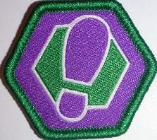
Milestone Badge 1 Participation Assist Lead
Nights/activities | 1 | 2 | 3 | 4 | 5 | 6 | 1 | 2 |  |  | 1
Community
Creative
Outdoors
Personal Growth
Awarded
- Check on your Term program for what parts have been done
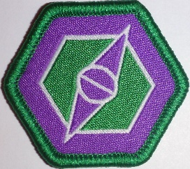
Milestone Badge 2 Participation Assist Lead
Nights/activities | 1 | 2 | 3 | 4 | 5 |  | 1 | 2 | 3 |  | 1 | 2
Community
Creative
Outdoors
Personal Growth
Awarded
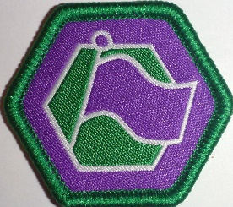
Milestone Badge 3 Participation Assist Lead
Nights/activities | 1 | 2 | 3 | 4 |  |  | 1 | 2 | 3 | 4 | 1 | 2 | 3 | 4
Community
Creative
Outdoors
Personal Growth
Awarded
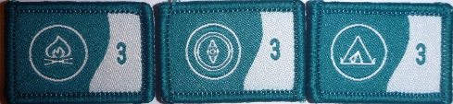
OUTDOOR ADVENTURE SKILLS OAS 3 Core skills * Check your LOG & Online
BADGE | STAGE 1 & 2 | STAGE 3 & 4 | STAGE 5 | STAGE 6 +
BUSHCRAFT
BUSHWALKING
CAMPING
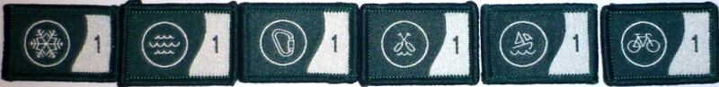
OUTDOOR ADVENTURE SKILLS OAS 6 other skills * Check your LOG & Online
BADGE | STAGE 1 & 2 | STAGE 3 & 4 | STAGE 5 | STAGE 6+
Alpine- skiing
Aquatics, swimmingEtc
Boating- sailing
Paddling, canoeing
Cycling
Vertical, climbing, cave

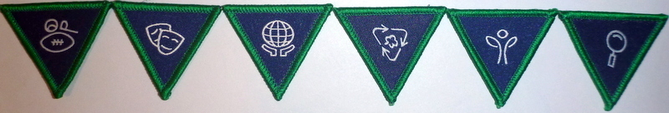
SPECIAL INTEREST AREA. * Your choice, design your challenge – 8 hours each
Adventure & Sport
Arts & Literature
Creating a Better World
Environment
Growth & Development
STEM & Innovation

See badges on separate sheet sample
ADDITIONAL AWARDS see Record Book
LANDCARE  Participate in 3 National accredited environment events. See book | Event 1: _______________  Time Spent : ___________  Date: ______ _________ | Event 2: _________________  Time Spent : _____________  Date: ______ _________ | Event 3: _________________  Time Spent : _____________  Date: ______ _________
FIRST AID  see Record book | Complete a 1st Aid Course with a Registered Training Organisation. | The training may be completed through workplace or volunteer training | Take an Update course annually
MESSENGERS of PEACE | Learn about the Messengers of Peace initiative in a Cub Scout meeting or online.  Date Completed | Participate in a community involvement action organised together with your Patrol.  Date Completed | Share your actions online with the help of an adult at scout.org/messenger of peace  Date Completed
THEIR SERVICE –OUR HERITAGE | Participate in 3 Activities | See Record book
WORLD ENVIRONMENT BADGE | Discuss with leaders | See Record book
CAMPER AWARD | Depicts total number of nights spent under canvas | Increments as 10, 25, 50, 75 & 100 nights | See LOG & Terrain records
WALKABOUT AWARD | Depicts total number of kilometres covered on Scouting Activities | Increments as 10, 50, 100, 150, 200, 300, 400 & 500 kilometres | See LOG & Terrain records
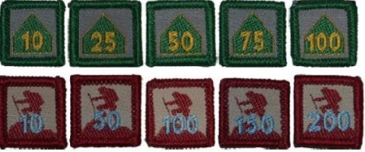

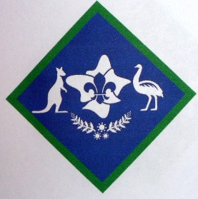
PEAK AWARD AUSTRALIAN SCOUT AWARD Dates
Milestone 3 badge-
Outdoor Adventure Skills 10 stages completed whilst in Scouts
Bushcraft Stage 5 Min if new to Scouts then 3 Core by 5 Stages = 15
Bushwalking Stage 5 min
Camping Stage 5 min
Others:
6 Special Interest Areas. Minimum choice of 3 from the 6 areas, 8 hours each
1.
2.
3.
4.
5
6.
Leadership Course at least 1 day
Adventurous Journey Plan & lead a journey of at least 3 days and 2 nights
Personal Reflection review of what has been achieved
Unit Council review

