“Bring a Friend” A plan to achieve 24 members
“A goal without a plan is just a wish”
Check out this Scouts NSW site first
www.nsw.scouts.com.au/members-services/promoting-your-group/
### We are generating interest in as wide a group of people that we can ###.
Then try this
Explain to the Pack/Troop that the normal number for an exciting section is 24 members.
This is what we want to achieve with the help of the Pack/Troop, leaders, parents and friends.
We are going to make a promotion pack to give to friends or anyone in the school or neighbourhood. We will also have entries in the school newsletter, banners & promotions.
Let mum, dad, brothers & sisters know that you are aiming for 24 boys and girls in the section and will they contact their friends to see if they are interested in trying out scouting.
We will also have a mystery box full of objects that are of interest to the age group.
This is the selling point for existing members to use when talking to friends.
The package & the mystery box (and any variations) should be used over and over until you reach 24 members. Get the girls & boys to put this package together.

Package for a friend Lanyard + flyers
Lanyard for school bag ? + Scout Adventure badge on a keyring + carabineer + koala + anything interesting. Maybe a lanyard also for the existing cubs/scouts.
Use paper “hole punch” to make a hole in the Adventure badge.
package
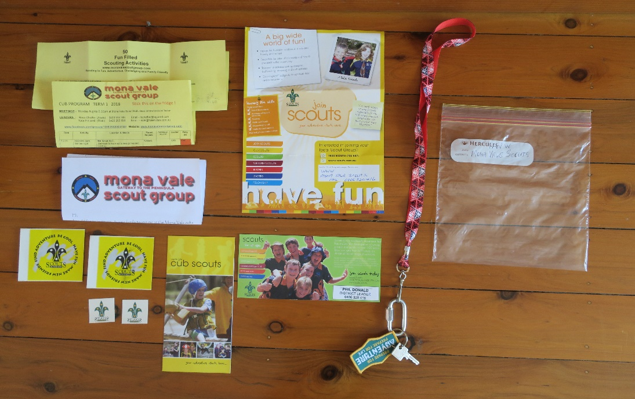

Flyers etc In the 22cm by 22 cm zip lock package bag will be
A Group letter or tag inviting a friend to the pack + the Term program and on the back “50 Fun filled scouting activities” + Scouting promotion flyer + Scout round stickers (and maybe scout transfers and scout balloon). Give these promotion bags to friends with the lanyard.
Have special nights programmed whilst the promotion is happening.
When the new chums come to the hall make introductions at the start, then games, activities then give them a sealed envelope with the combination/key to the mystery box and let them “borrow” anything in the box. They can swap/keep it next week and so on until invested.
As an incentive have a 2nd plastic box with something for existing members ie from the discount shop, water pistol, torch, game, frisbee. Something the they can play with other friends.
**** This is all about drumming up interest in the section. Think outside the box. ****

Ongoing weekly promotion
New Zip packs can be handed out and a short discussion on what is working and ideas floated around. New chums can take a pack to give to their friends Plan Do Review
Give every member 6 invitations to give out including 6 for parents.
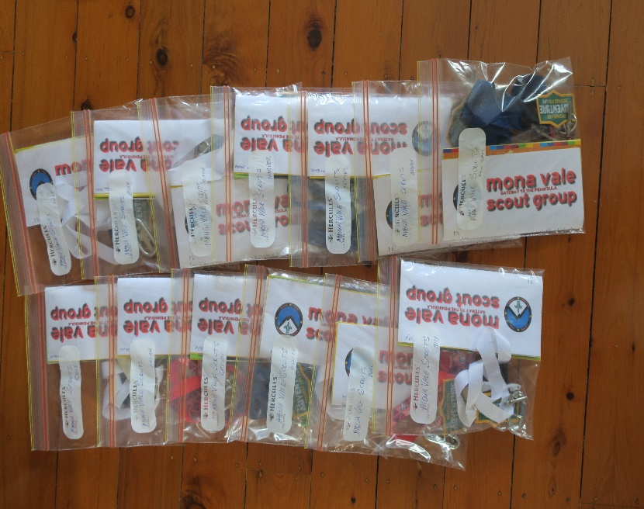
This will have a flow on to other Sections which is a bonus or they can also bring friends

Ok So let’s get all the pieces of the jigsaw ready

On Line. Order a free promotion (or buy) pack from the State office. You may not want flyers for Leaders or Venturers, be selective.
The Group may already have cub/scout flyers in the office.
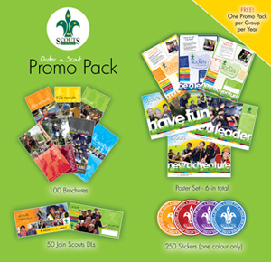
www.nsw.scouts.com.au/members-services/promoting-your-group/order-a-promo-pack/

If you want a large order & also balloons or transfers etc then go to (payment req’d)
www.nsw.scouts.com.au/wp-content/uploads/2018/03/Scouts-NSW-Promo-Order-Form.pdf

Order badges and books from The Scout Shop (or local shop)
Log onto Scout Central and go to top RHS for Scout Shop.
https://login.scouts.com.au/login

Badge. “Prepare for Adventure” buy approx. 40 +
1 for each cub/scout you have and 1 for a mate + future weeks.
You cannot have enough. Maybe cubs pin them on their shirt for some weeks
Punch a hole for keyring with paper hole punch. Have a six/patrol challenge each term.
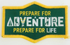

Books. One for Cubs & Scouts Buy approx. 10 Hand out to new chums on the 2nd week.
Allocate a Sixer and PL to go through the book with them or their mate. The $ cost is worth it.
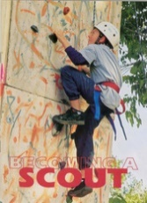

“Swap bag” pack. Buy 2 packs or use badges from leaders and the office. Stick the badges on the boxes. Bright ones ! Cut up some Scout posters and stick on. Have the members do this.
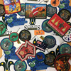

Badge “Bring a Friend”. Buy approx 10. Issued at the leader’s discretion to current cubs/scouts for recruiting. Some cubs/scouts specialise in recruiting so make a fuss as they bring new chums in.

Everyone in the Group needs to understand that this is a Group effort (leaders, children and parents) to get to 24. Discuss at all meetings.

Get the pack/six/troop/patrol to make up posters to put around the hall.
Program interesting outings.

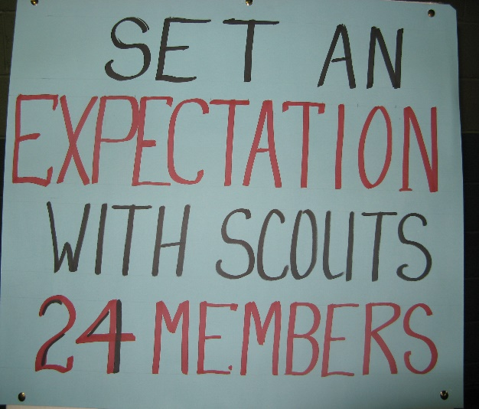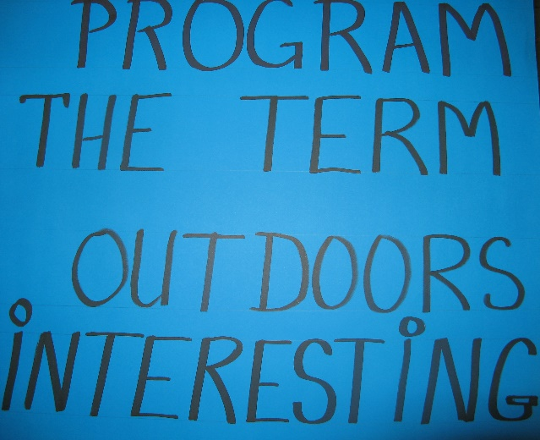

This should be at every planning meeting
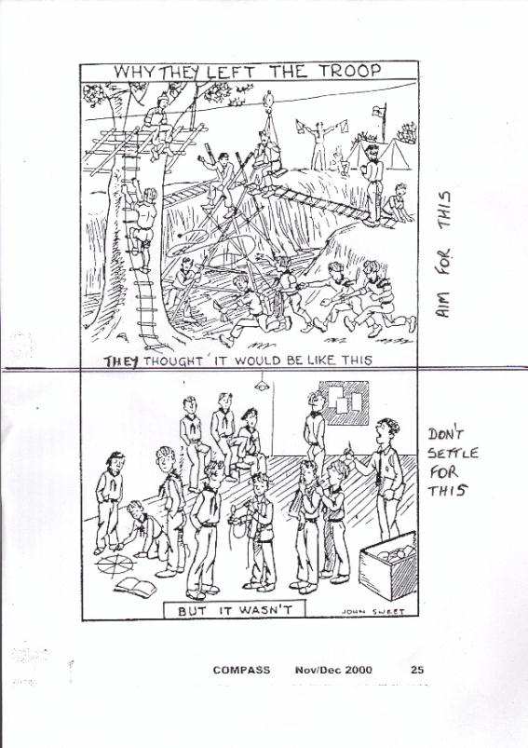

Make Mystery boxes with the cubs/scouts to get them interested in Bringing a Friend
Maybe plastic box and stick badges and posters over it. As long as it is interesting & part of the program.
Buy a stack of interesting things for the Mystery Box from the Discount shop or bring from home/hall.

Box 1 is for existing cubs/scouts to select something to show or play with their mates. “Look what the pack is doing “
It is a reward and a challenge to get the pack up to 24.
Water pistol, small torch, game? ask them for suggestions
Take them shopping, give each six/patrol $10 and see what they get.
Plan a mystery box construction night.
Maybe they bring unwanted items from home that can go in the boxes.

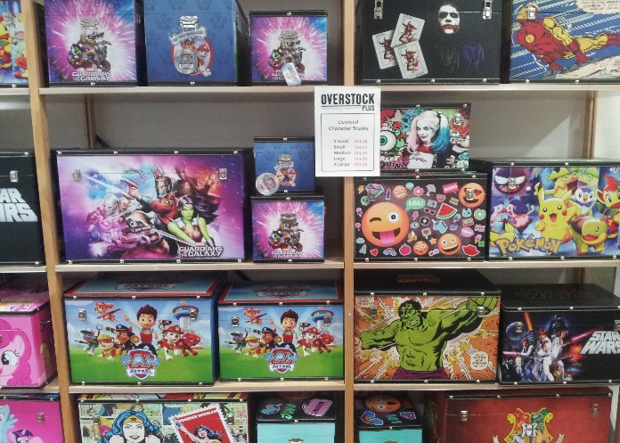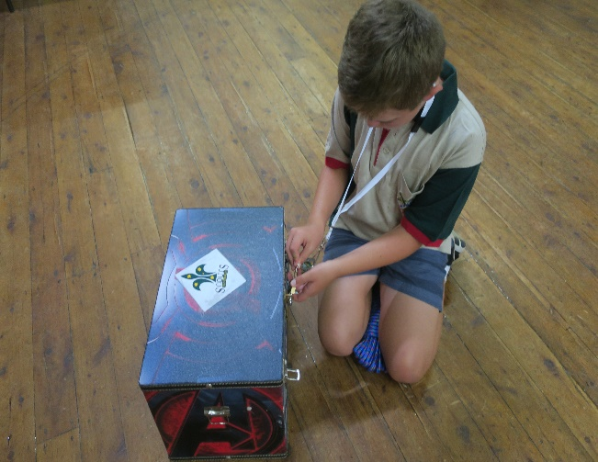

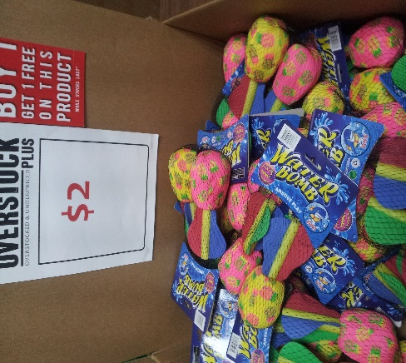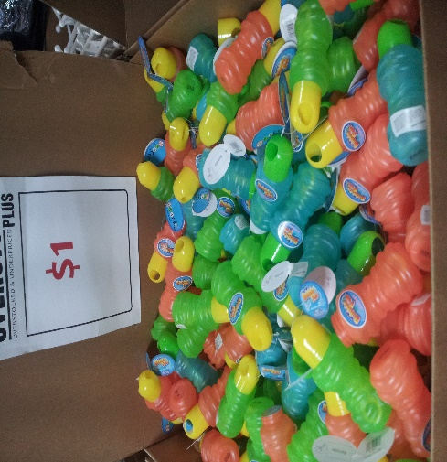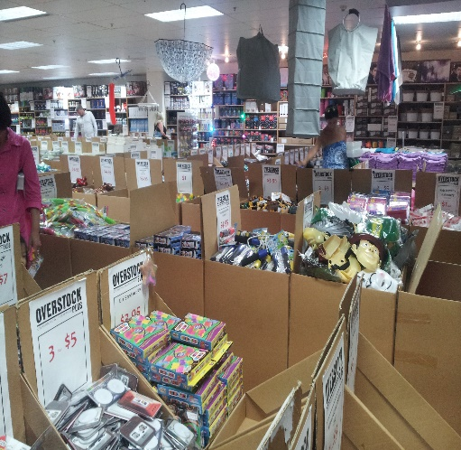

Mystery Box 2 for new chums who get invited
This is the Pack/Troop’s most awesome box. It could be a small decorated/painted patrol box.
It may have a combination lock or normal lock on it and they have to tell the pack something to get the combination or key from a sealed envelope etc

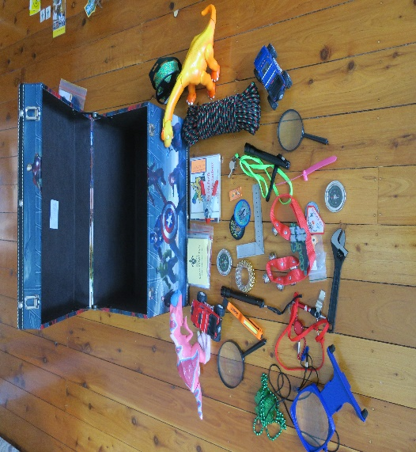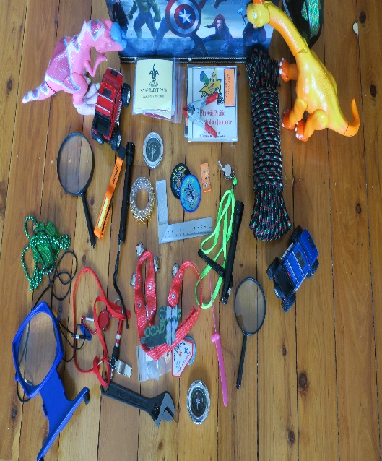

After all this happens
Every night the pack/troop makes time to discuss how they are going and how to get to 24
They will come up with lots of good ideas for future nights. Persist with the theme, also with parents.
Get the pack/troop to make a chart on the wall that starts at the current number and they add to it as new members arrive.
A Grey Wolf or challenge badge? Try drawing the new chum and stick him on the wall.

Banners
A banner or flyer on the school gate/notice board is seen by hundreds of children including parents.
The hand painted “A” street board is very effective (maybe the scouts make a few).

One pack leader made this insightful observation , thank you.
"We stopped bring a friend nights. We run a program written by the cubs. They will always come to what they want to do, so let them write the program. Get them to cover 3 boomerang tests per term, a community service, a challenge and the rest is up to them. We also let them run it, with guidance. Youth led adult supported really works! Have a public Facebook page and share photos of the cubs doing stuff to your local community pages. Don’t advertise or recruit via Facebook posts, it turns people off. Just show them what the cubs are doing. We went from 9 cubs and struggling mid 2016 census to pushing 30 right now, and we get continuous enquiries from our Facebook posts. We've also had 8 grey wolves in that time. And it’s a flyspeck of a town too"

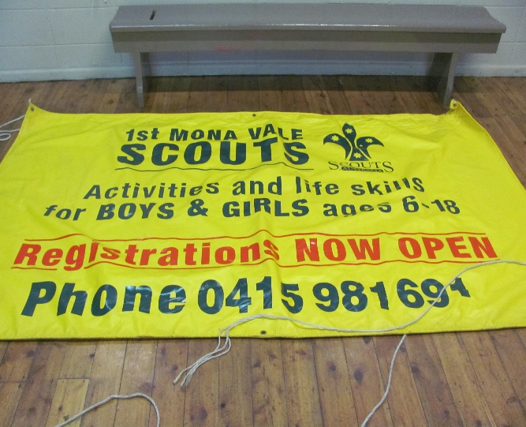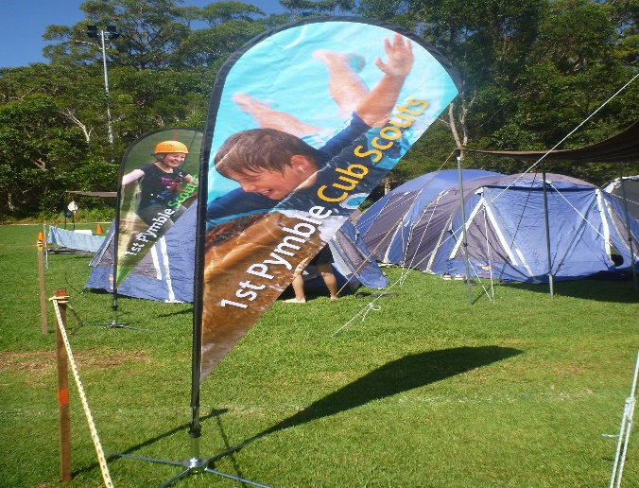

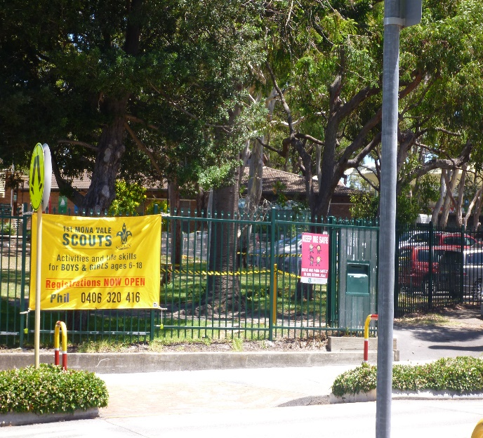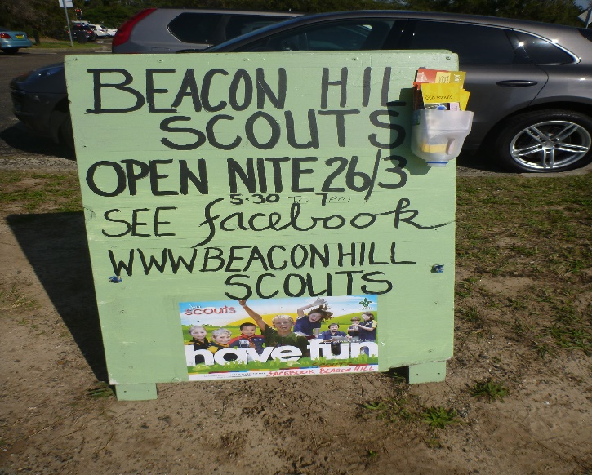

Ingleside Cubs, Scouts Recruiting Now

The Scout Group is recruiting 6 - 14 year old boys & girls to become Joeys, Cubs & Scouts.
Do you want to get your kids off the computer and back outside. Why not look at Scouting. Your children can try anytime throughout the year for 4 - 6 weeks without you paying any money, so if they don’t like it, then you don’t pay.
We teach your children leadership skills, resiliance, confidence, all by playing games and having fun. Scouting worldwide is led by parents just like us.
We do it all: games, crafts, cooking, fishing, community service, compass work, canoeing, bushcare, more games, skits, camp fire fun, songs, knots, swimming, first aid, bike riding, surf safety, more games, camps, movie nights, bushcraft, lots and lots of outdoor activities, end of term parties, so, so, so much more.
Check out our website: www.inglesidescoutgroup.com & facebook page
Contact Pam 0409 123 456 or inglesidegroupleader@gmail.com
Joeys 6-7 yo Mon 5 to 6pm. Cubs 8-10yo Tues 6.30 to 8pm
Scouts 11-14yo Thursday 7-9pm Or just turn up at the hall 15 Palm st, but be warned, we may be away on an adventurous activity.

This flyer can go on anything and anywhere in the district. Discuss with members as to how, when, where.
Plan a night to make them and attach to cardboard etc. Distribute and post up on late night shopping days ?.

Social media
Create a free site on Weebly.com https://www.weebly.com
Open a facebook page www.facebook.com

INCENTIVE
There will be a PARTY when we get over 20 ?

Group Leader - Welcome email sent as soon as you have an email address
Tailor each email to suit the family

Caroline & family, welcome to Ingleside Scout Group.
The Cubs meet on Monday nights in School terms. (7.5yo to 11yo+. 6.30pm to 8pm) at the hall, located at 17 Barrenjoey Rd. The scouts 11 to 14yo meet on Thursday night 6.30 to 8.30pm. You are welcome to come along for some weeks to see what scouting is all about.

The cubs are run by the parents and a Group team and there are no paid employees which is common in scouting throughout the world. Talk to our cub leader David as to what you can do to make it a fun time for all concerned. The Scout Association will train all parents & friends interested in outdoor activities, games, camping, bushwalks, exploring, cooking, canoeing, sailing, youth leadership, etc

Samples of scout groups in the area.
Brookvale Scout Group http://www.brookvalecurlcurlscouts.com/
Mona Vale Scout Group www.monavalescoutgroup.com/index.html
Mona Vale Facebook page www.facebook.com/monavalescouts/
Ingleside Scout Camp http://www.inglesidescoutcamp.com.au/
Cubs & Scouts various activities www.cubstuff.info/
Scouts NSW www.nsw.scouts.com.au/about/youth-program/cubs/

By becoming a member of Scouts Australia, your children are joining the largest youth movement in the World with over 26 million members in 220 countries.

Scouting's aim is to develop character and good citizenship and this, for the most part, is achieved through fun and experience gained in outdoor activities. Hiking, camping, canoeing, bush walking and learning to fend for oneself teaches the young person self-reliance and how to work with others for the mutual benefit of all. In essence, the basis of Scouting's continuing success is that it uses the young person's natural desire for friendship, fun and adventure to turn them into useful and thinking citizens so subtly that they are unaware of it happening.

Scouting makes full use of the need for adventure and the vivid imagination of young people. Games of all kinds, outings and camps, hikes, yarns, and skill development activities are combined to form a unique programme for young people of all ages.

An Award Scheme operates in each Section (joeys, cubs, scouts, venturers) which allows the members a wide variety of activities and skills in which they can participate and receive recognition with the awarding of an appropriate badge. These awards are graded to the person's age and ability. Through all Sections there is the continuing opportunity for young people to work together learning co-operation, responsibility, leadership skills and the sharing of group experiences.

As a parent, I am sure you are vitally interested in the welfare, both physical and mental, of your child and we welcome the opportunity to work with you and see your child develop into a good and useful citizen. Our Group provides the opportunities for parents to become involved in Scouting by joining us as a leader or supporting the Group's many activities.

Scouting, along with home, School and Religious Organisation will assist your child to become a better member of the community. With your help either as a Leader, Committee person, Instructor, or Examiner, your child will enjoy their experiences in Scouting and will benefit greatly from them.

I am sure your family will enjoy being involved with Scouting and we look forward to seeing you over the following weeks.

Yours in Scouting
Group Leader Plan, Do, Review
1st Ingleside Scout Group 0406 123 456
groupleader@inglesidescouts.com.au

If you have any suggestions or comments post to Phil
northernbeaches@sydneynorthscouts.com

