Resources for Trainees & current leaders samples
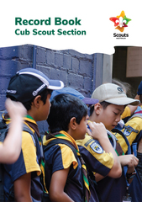

Fieldbook Joey ideas games etc
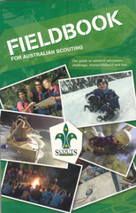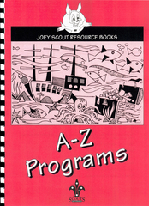

Cubs the PAWS book series PACK HOLIDAYS, PROGRAMS FOR MEETINGS , QUIZES, COOKBOOK, SPECIIAL NIGHTS, THEMES FOR TERM, NATURE & OUTDOORS, SKITS & PUPPETS, DUTY TO MY GOD. $5 & $10 each

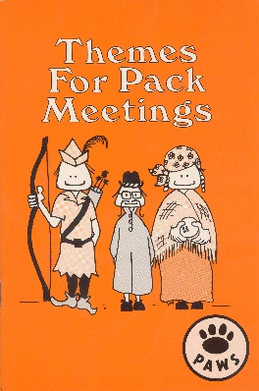 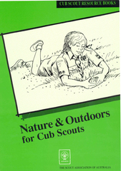 plus six more

SCOUTS Ventures
Camping & Hiking book “This book is not program specific so whilst written a few
years ago is still relevant to todays program”
