Be Prepared... to hop into adventure!
Joey Scouts (6-7)
 | Do you know how to cook chocolate spiders or make frog puppets? Can you build monsters and spaceships from scrap items? Have you ever grown a plant or hiked in the bush?  These are all things you can learn when you are a Joey Scout!  Joey Scouts are boys and girls aged six and seven who like having fun and making friends!  When you join Joeys you’ll be part of a Mob. You’ll play games, read stories, sing songs and do craft activities.  You’ll find out about nature and learn about native birds and animals.  You might fly a kite, go bushwalking, go to the beach, or visit a fire station, zoo or farm.  The Joey Scout theme is HOP – Help Other People! You’ll learn to jump in and HOP, and to share with your friends.  You’ll also learn heaps of useful stuff, like what to do in an emergency.  When you join in different activities and learn new things, you and your mates in the Mob can earn special badges to sew on to your Joey Scout shirts. | 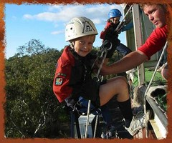  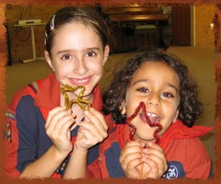  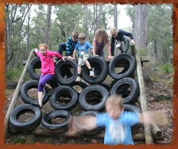  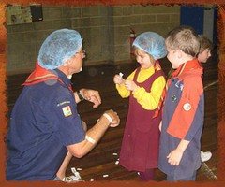  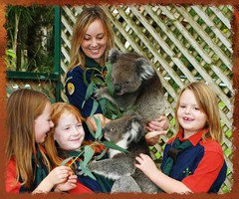
To start your Scouting adventure, ask your parents to bring you along to free 3 week tryout at :
Contact:

