Sample idea, print on coloured paper. Give 6 copies to every family
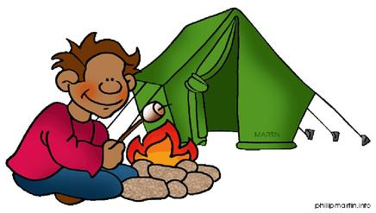

Ingleside Scout Group
Adventure, games, learning by doing
Open Nights from Monday 25th from 5.30pm
Hi,
I would like to invite you & your family to join us on Monday to see what scouting is all about & to enjoy a special night of activities.
Scouting is all about learning by doing and testing your limits.

Our Group activities include hikes, camps, swimming, bike rides, cooking, camp fires, skits, singing, games, leadership and growing up with mates.
Our 1st open night is Monday 25th from 5.30 to 7.30pm, drop in anytime.
You are welcome to come along for some weeks free and try it out and best to bring a friend if you want to.

Welcome to the world of scouting

Your parents can contact our Leader –

Dave Miles on 0409 111 222 or lotsofsmiles@bigpond.com
or go to our website www.inglesidescoutgroup.com
or facebook page facebook Ingleside scouts

Joeys are 6 & 7 yo. Cubs are 8,9, 10 yo. Scouts are 11 to 14 yo

