Promoting scouting in schools & community
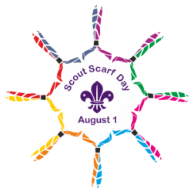1st August. World Scout Day and Scout Scarf Day

“The idea of "Scout Scarf Day" on World Scout/Guide Day August 1st is that all active and former scouts are requested to wear their scout scarfs in public to make the "Spirit of Scouting" visible:
Once a Scout - Always a Scout!
The date of the scarf up event commemorates the very first experimental camp in England by Baden Powell on Brownsea Island in 1907. It is also the day that Scouts Australia publish Adult Recognition Awards for services to scouting.
Of course, the scarf is only a symbol but a strong symbol for the scout promise and for our mission to leave the world as a better a place than we found it”.
https://en.wikipedia.org/wiki/Humshaugh#First_official_Scout_camp

*This promotion idea could also be used throughout the year for any other scouting milestones.
Founders day, 100, 110 ! years of Cubs, Scouts etc or 40 years for your Group. Peak awards etc

http://www.scoutscarfday.com/ https://sydneynorthregionscoutsresources.weebly.com/ Promotions

This is a great opportunity to do a promotion in your schools (or workplace). Each school no matter whether a primary or high school has time set aside for discussions & presentations on community and world events. This can also happen in colleges & universities. They can be in the classroom or at an assembly.
Each week schools invite guests to present something of interest to the students.

*It is a matter of establishing with the school how, when, where and why the scouts could do a presentation.

Check out the other files for actually doing a presentation

For a stack of other ideas go to the promotion website that leaders in Oz have contributed to

https://sydneynorthregionscoutsresources.weebly.com/promotions-recruitment-retention.html

