Patrol Badges
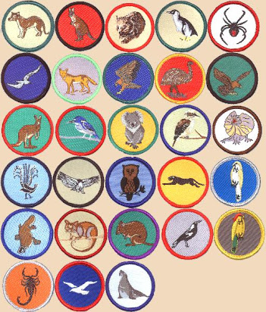
6 Special Interest Areas & 3 Milestones (approx. year 1, 2 or 3)
Joeys, Cubs, Scouts, Venturers, Rovers (samples, different colours each Section)
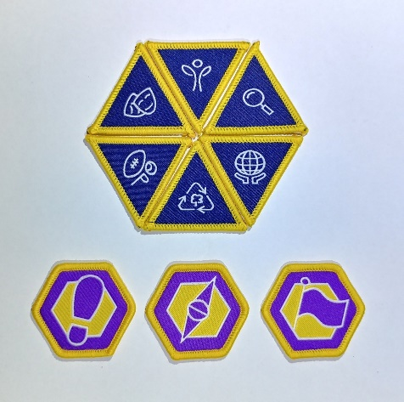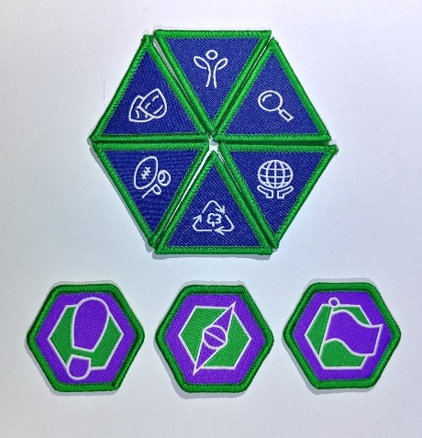
Outdoor Adventure Skills Joeys to Rovers. See OAS book or online
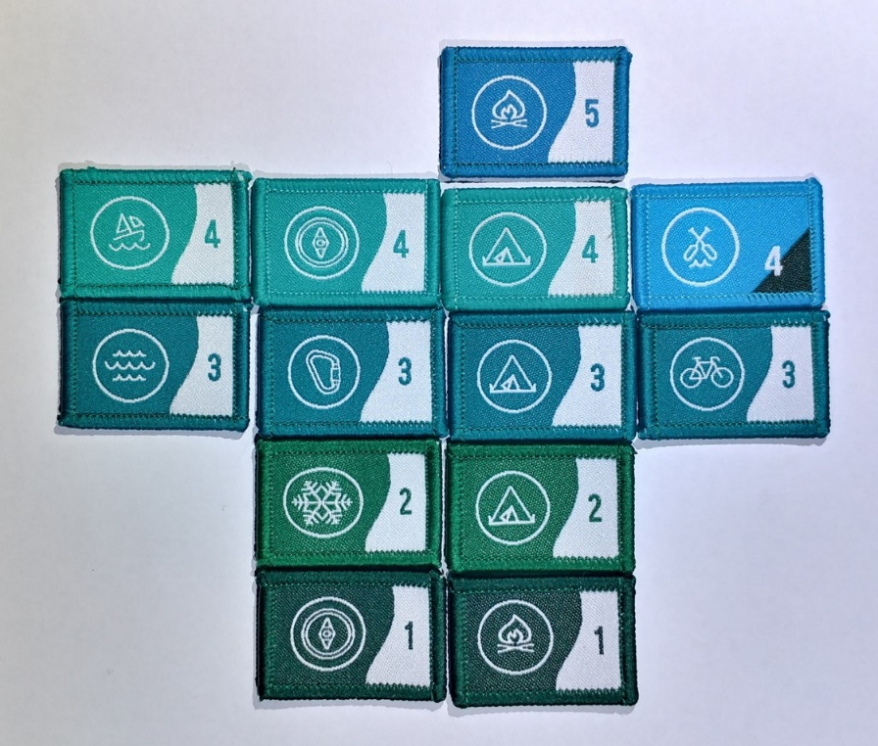

Camper and Walkabout Joeys to Rovers

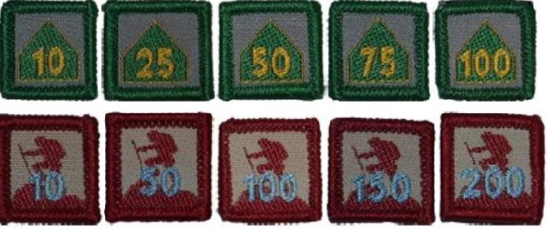

The Camper Award Badge shows the number of nights spent camping while on approved Scouting activities (School camps and family holidays do not count.)
The Walkabout Award Badge is earned for the total kilometres travelled under human power through a youth’s time in Scouting. Journeys taken in a canoe, kayak, skis or a bicycle are divided by 2 to calculate the distance to add to a Scouts distance history.

Youth years of service badges any Section Sample Cubs
From the time you are invested as a Joey Scout, as the first year clocks over, you are presented with a "1" year Service Award badge. If you're in Joeys for 2 or even 3 years, you will replace your "1" Badge with a "2", then a "3". Your last “year” badge from each Section can “stay” on your uniform right through Cubs, Scouts, Venturers and Rovers
Joey Scout Challenge
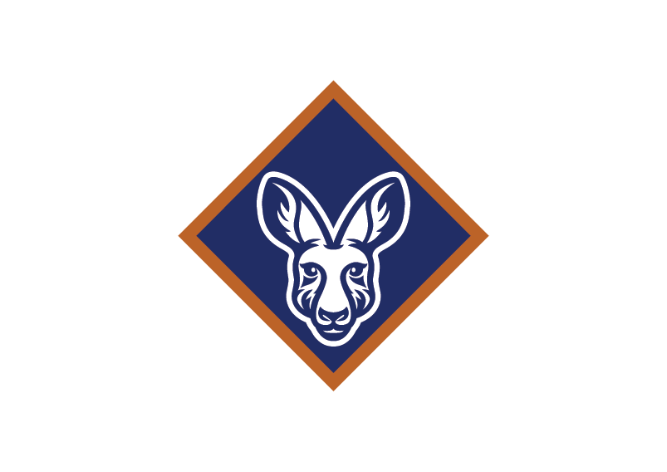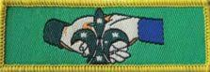
Bring a Friend badge

Cub Scout Grey Wolf Award Cub Leadership Course
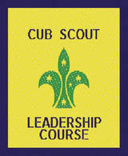
Introduction to Section
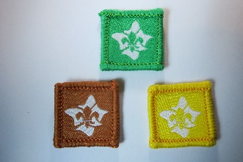 or similar badge
Australian Scout Award Leadership course
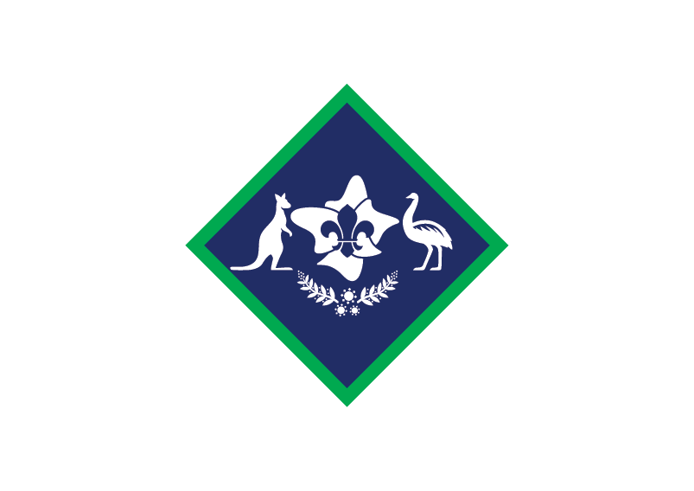 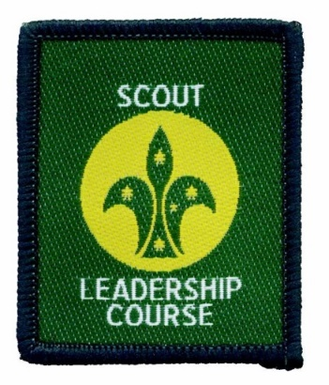 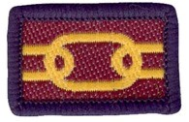 Introduction to Section or similar badge
Venturers Queen Scout Award
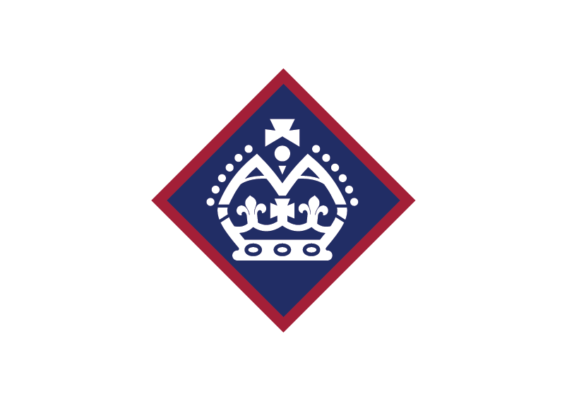
Rovers Baden-Powell Award

