Additional Badges 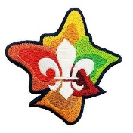
For details of these badges either go to Scout Central then Scout Shop & Sign In, click Badges (Joeys to Leaders) & click on the badge & then click on the details OR go to your Record Book (new or old). Badges are not for all Sections
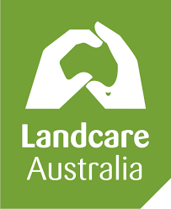 | Landcare Badge  Participate in any 3 Landcare projects for a period of ten hours either through their local Scout Landcare Group or as part of a community Landcare Group. For details see Record Book.
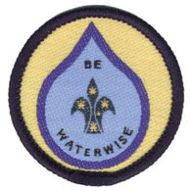 | Waterwise Badge In order to gain this badge, Cub Scouts are required to complete any six of the “Waterwise” activities. They may be completed as a Pack, as an individual or as a small group such as a Six. If the activities are done individually, Cub Scouts need to report to their Pack on what they have learnt. See Scout Shop
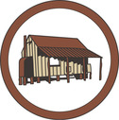 | Local History Badge Our local history is important, and this is an opportunity to learn more about it Through this badge you will learn more about your own community and Australia history and how Scouting has played a part in this history. See Scout Shop
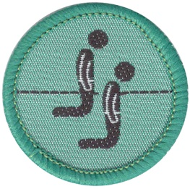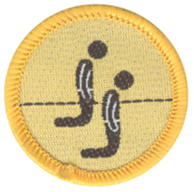 | Faith Awareness Badge Cubs & Scouts  Youth members are eligible to earn and wear the Faith Awareness Badge. The badge may be earned in any Section. The Badge Adviser will be called a Religious Adviser. The Religious Adviser may be a Minister of Religion, Priest, Rabbi, Lay Helper or religious equivalent. See Scout Shop
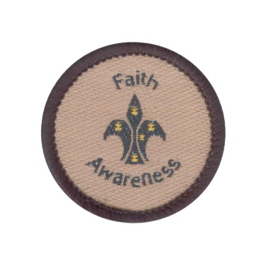 | Faith Awareness Badge Venturers & Rovers  This Faith Awareness badge was designed to be worn by those members of any Section who have met the criteria for the Faith Awareness special badge and who’s religions do not involve kneeling and who therefore feel it inappropriate to wear the Cub and Scout Faith Awareness badge designs.  It is also the badge that should be worn by Venturers and Rovers who attain the Faith Awareness badge in their Youth Section. See Scout Shop
 | World Scout Environment Badge The World Scout Environment Program helps Scouts around the world work together for the good of the local and global environment. see Record Book
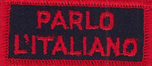 | Language Emblem Badge Standard emblems currently include Danish, Mandarin, Cantonese, see Record Book
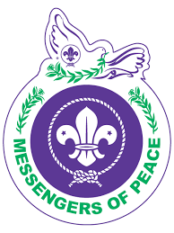 | Messengers of Peace Badge  Messengers of Peace is a global initiative, its aim is to create a better world globally by acting locally. Through the Messengers of Peace Online Platform, it aims to connect people from every National Scouting Organisation through the sharing of peace projects. see Record Book.
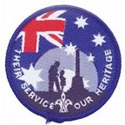 | Their Service, Our Heritage Badge  This award was introduced with the intention of raising the level of awareness of youth members about our Veterans and providing Scout members with an opportunity to actively participate in the 'Their Service - Our Heritage' program.  This is an annual award and is achieved each year with the year commencing on 25th April. The badge will have a different coloured edging each year.  see Record book
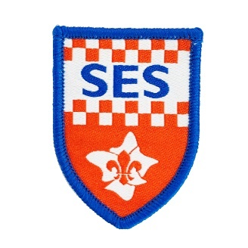 | The SES badge may be earned through engagement with the SES.  The requirements for each section will vary, with sustained engagement required of members in the Venturer Scout and Rover Scout sections. See Scout Shop
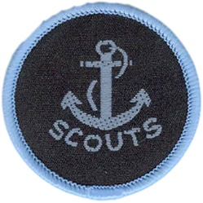 | The Anchor Badge is the official National water activities badge, worn by Members qualified in level 1 or level 2, Sailing, Canoeing and Power Boat water activities.  See Scout Shop
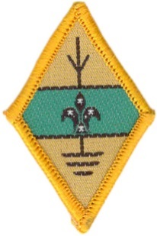 | The Amateur Radio Operator Badge  The badge is issued on the authorisation of the Branch Jamboree on the Air Co-ordinator and a register is kept at Branch of their issue. Details on www.acma.gov.au  NOTE: To be purchased by Scout Branches Only. BHQ  See Scout Shop
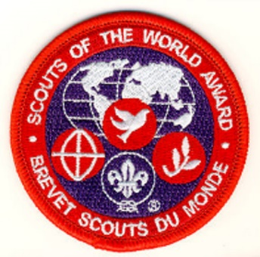 | The Scouts of the World (SOW) award provides the opportunity for Venturer and Rover Scouts to “Create a Better World”. Through facing the challenges of the future as identified by Sustainable Development Goals of the United Nations see Record Book Venturers
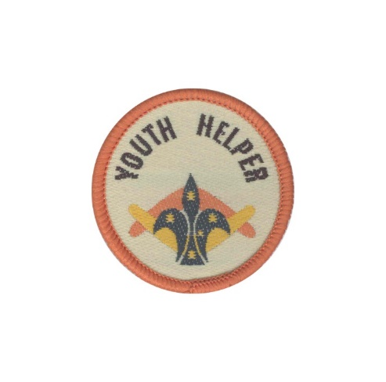 | The Youth Helper Badge is for Venturers who are assisting with the Joey, Cub or Scout sections as a Youth Helper. Often this is done as part of a Venturers Queen's Scout service but can also be continued as ongoing support to a youth section. see Region/District Leaders.
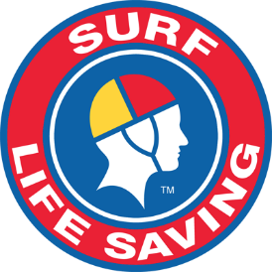 Sample only | Lifesaving Badge Venturers Bronze Medallion level or higher see Record Book
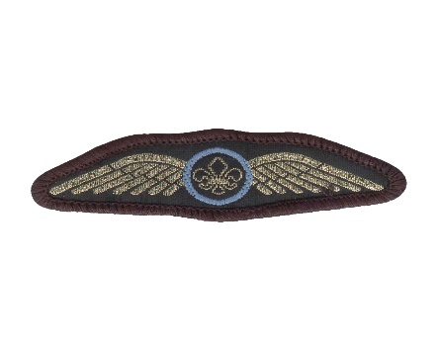 | The Pilot Wings Badge is presented by Scout Flying Schools and may be worn by qualified uniformed members. see Record Book Venturers
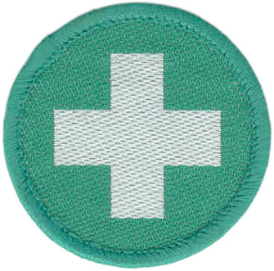 | First Aid Badge may be worn by members who hold a current first aid certificate from a Registered Training Organisation.  The training may be completed through workplace or volunteer training.  Submit your certificate to the State/Region office for registration on the State database. see Record Book

