Badges available to the Sections
Patrol Badges
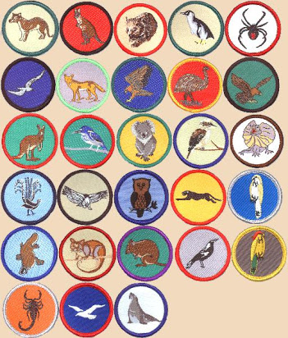
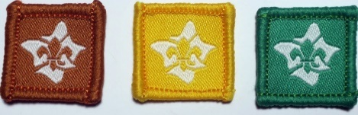 Introduction to Section or similar
Joeys. 6 Special Interest & Milestones 1, 2, 3
Adventure & Sport, Arts & Literature, Creating a Better World, Environment, Growth & Development ,
STEM & Innovation
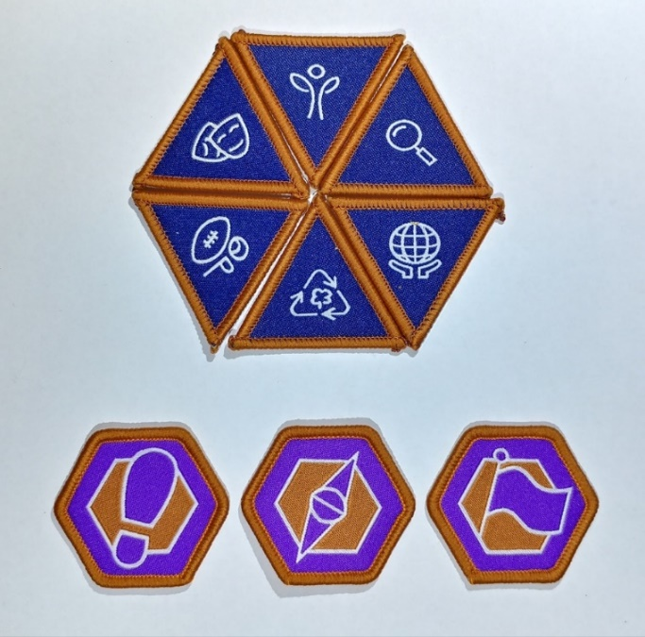
Cub Scouts. 6 Special Interest & Milestones 1, 2, 3
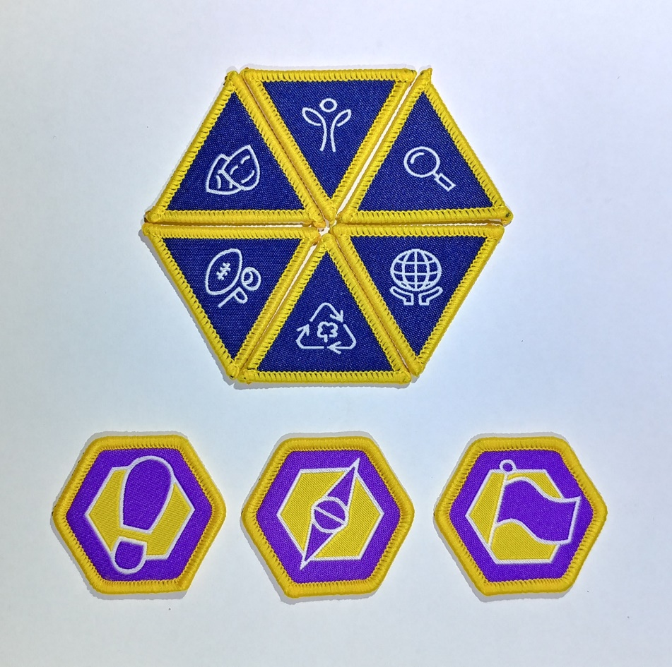

Scouts. 6 Special Interest & Milestones 1, 2, 3
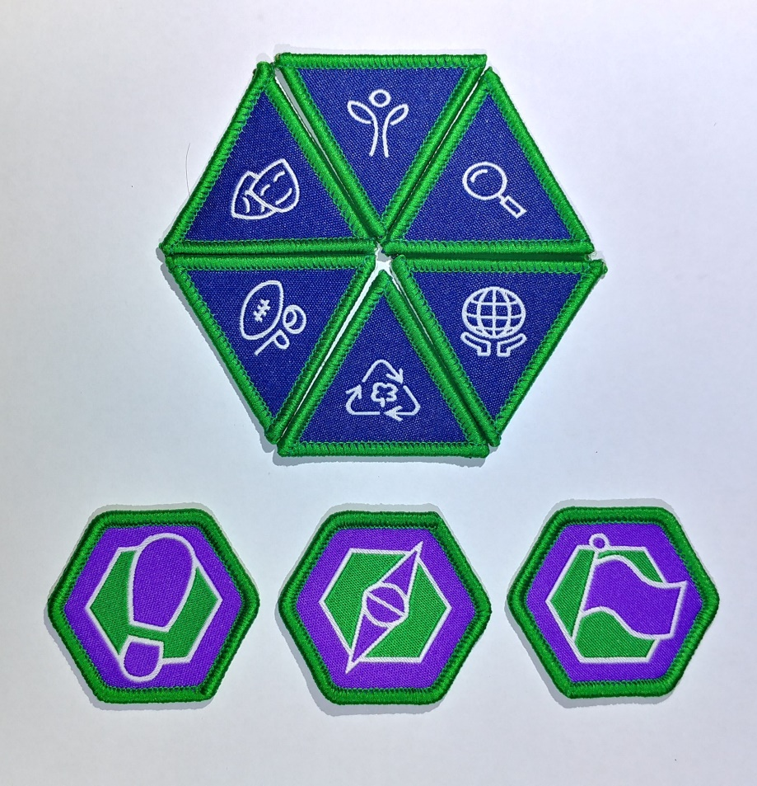

Venturers. 6 Special Interest & Milestones 1, 2, 3
Badges not shown
Rovers. 6 Special Interest & Milestones 1, 2, 3
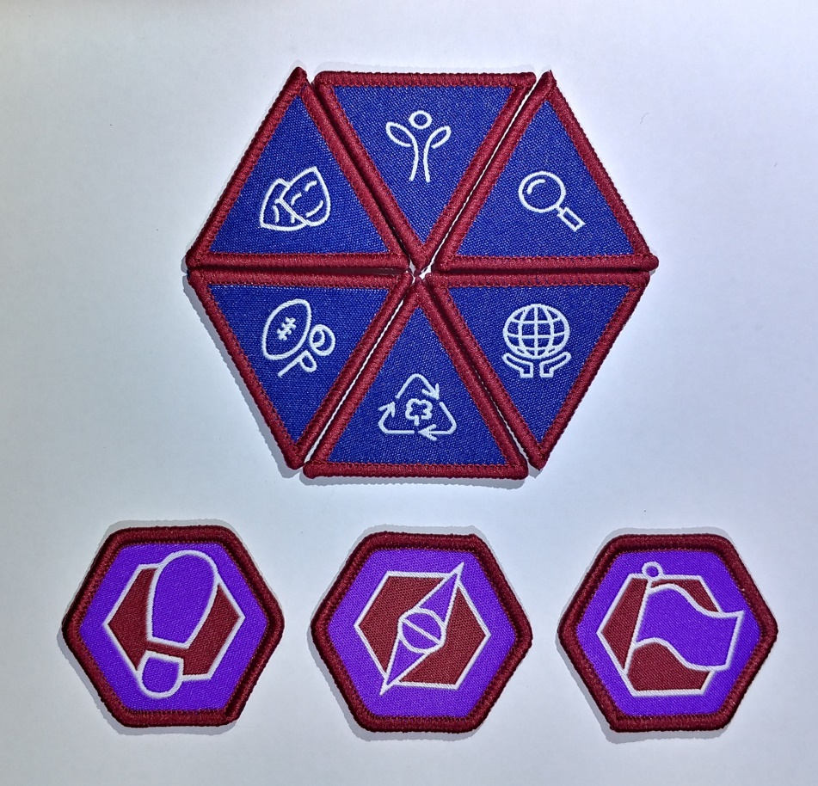
Outdoor Adventure Skills Joeys to Rovers samples
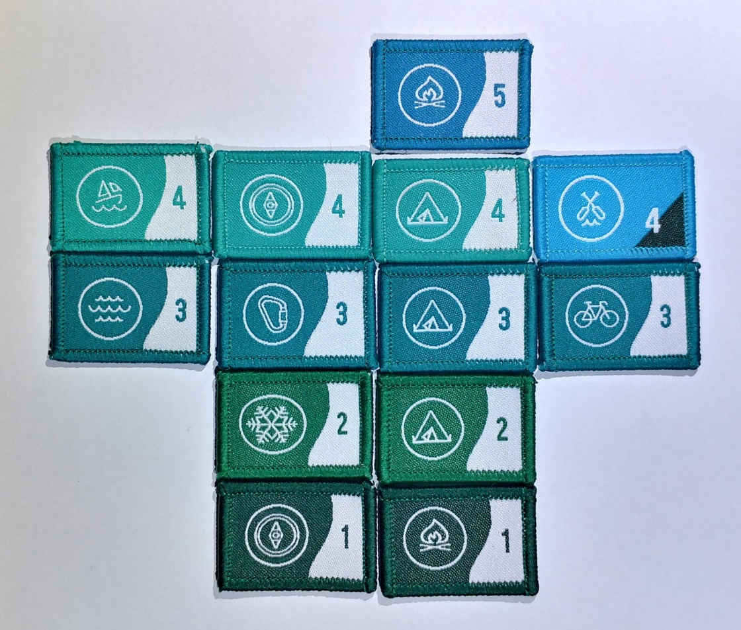
Camper and Walkabout Joeys to Rovers
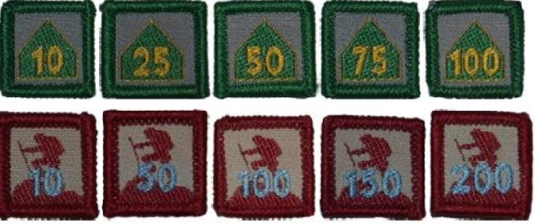

The Camper Award Badge shows the number of nights spent camping while on approved Scouting activities (School camps and family holidays do not count.)
The Walkabout Award Badge is earned for the total kilometres travelled under human power through a youth’s time in Scouting. Journeys taken in a canoe, kayak, skis or a bicycle are divided by 2 to calculate the distance to add to a Scouts distance history.

Youth years of service badges any Section Sample Cubs
From the time you are invested as a Joey Scout, as the first year clocks over, you are presented with a "1" year Service Award badge. If you're in Joeys for 2 or even 3 years, you will replace your "1" Badge with a "2", then a "3". Your last “year” badge from each Section can “stay” on your uniform right through Cubs, Scouts, Venturers and Rovers
Joeys Joey Scout Challenge Award
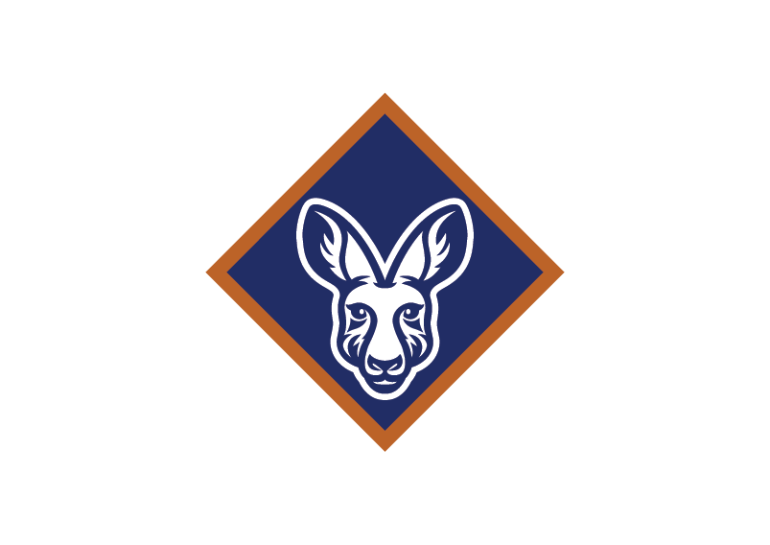
Cub Scouts Grey Wolf Award
Bring a Friend badge
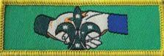

Scouts Australian Scout Award
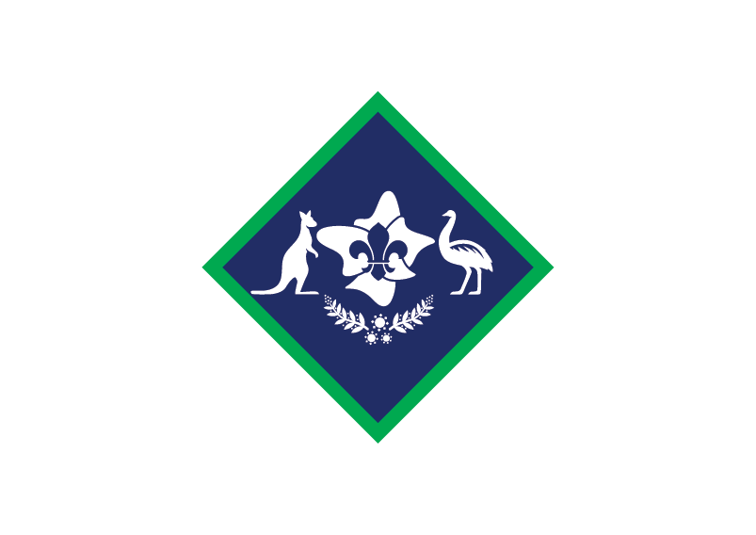
Venturers Queen Scout Award
