Badges available to the Sections
Patrol Badges
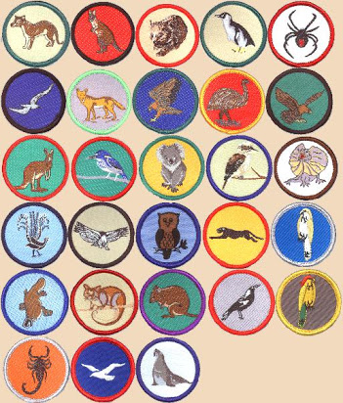
Joeys. 6 Special Interest & Milestones 1, 2, 3
Adventure & Sport, Arts & Literature, Creating a Better World, Environment, Growth & Development ,
STEM & Innovation

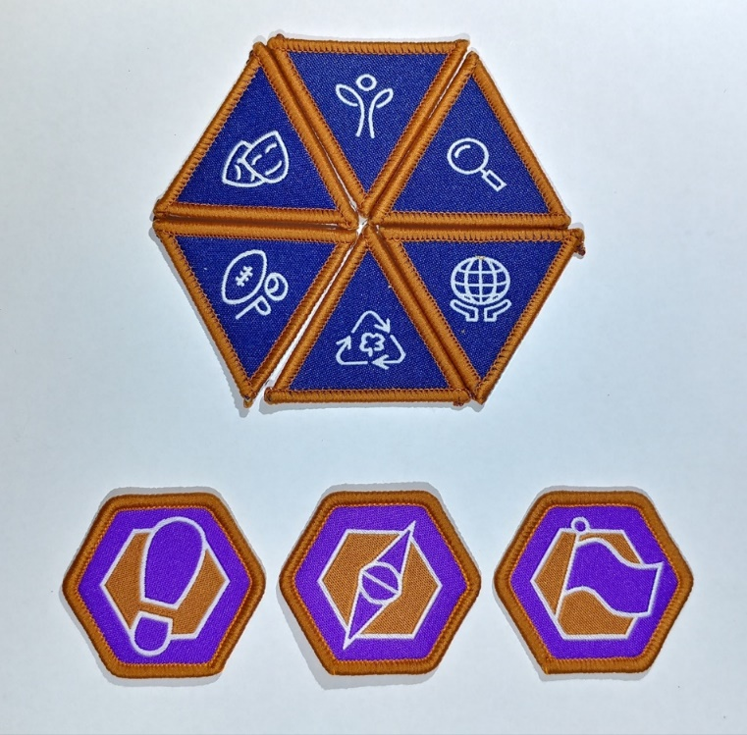
Cub Scouts. 6 Special Interest & Milestones 1, 2, 3
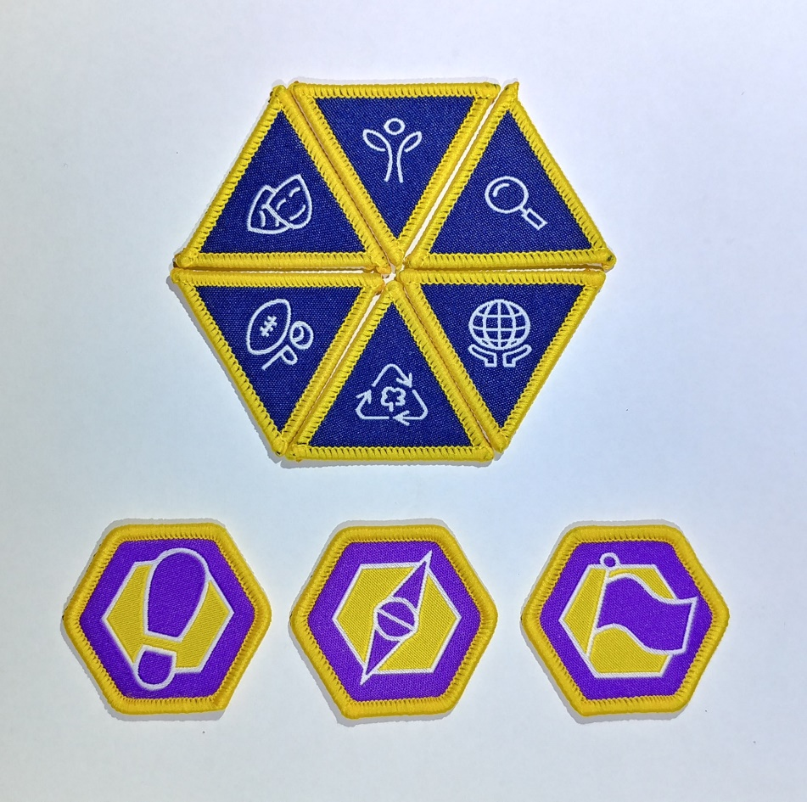

Scouts. 6 Special Interest & Milestones 1, 2, 3
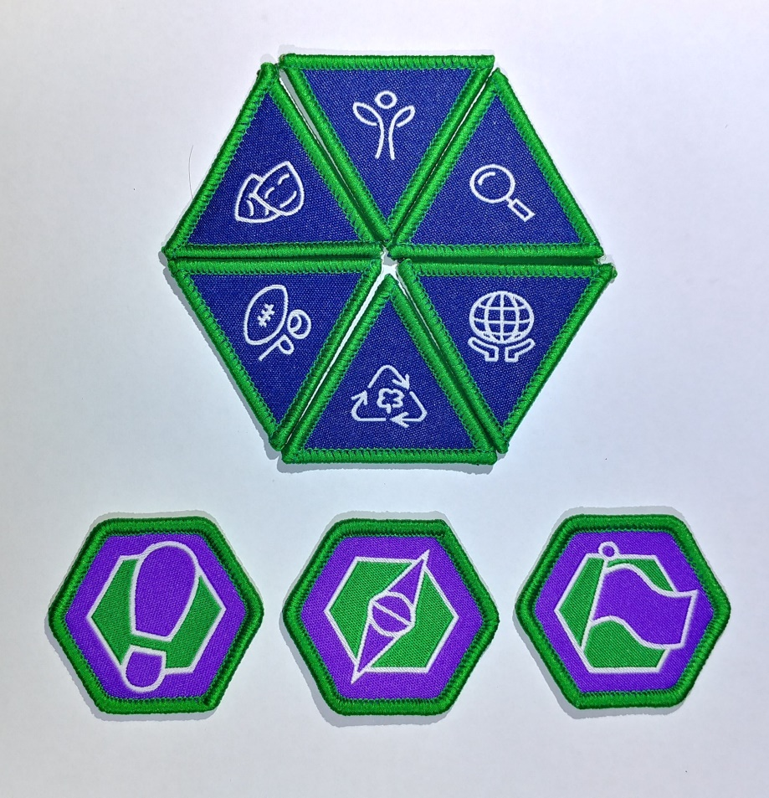

Venturers. 6 Special Interest & Milestones 1 2 3
Badges not shown
Rovers. 6 Special Interest & Milestones 1, 2, 3
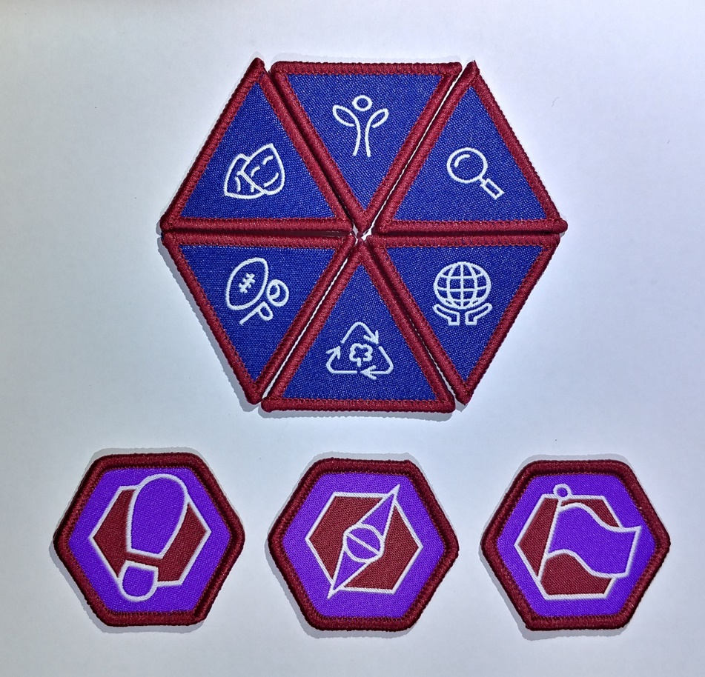
Outdoor Adventure Skills Joeys to Rovers
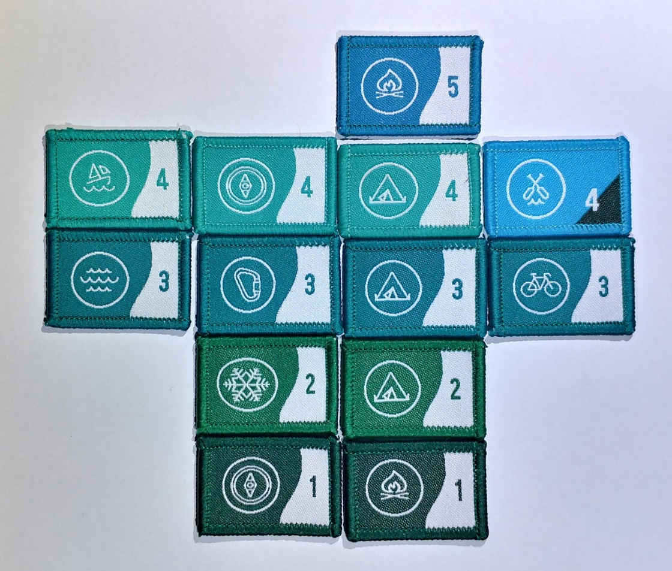
Camper and Walkabout Joeys to Rovers
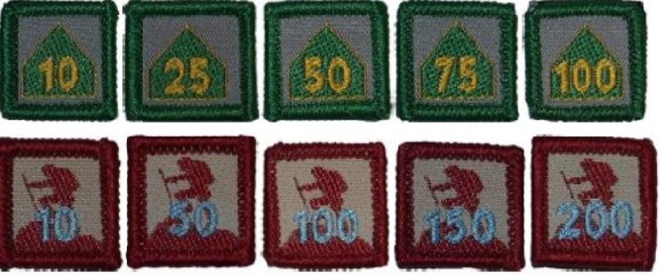

The Camper Award Badge shows the number of nights spent camping while on approved Scouting activities (School camps and family holidays do not count.)
The Walkabout Award Badge is earned for the total kilometres travelled under human power through a youth’s time in Scouting. Journeys taken in a canoe, kayak, skis or a bicycle are divided by 2 to calculate the distance to add to a Scouts distance history.

Youth years of service badges any Section Sample Cubs
From the time you are invested as a Joey Scout, as the first year clocks over, you are presented with a "1" year Service Award badge. If you're in Joeys for 2 or even 3 years, you will replace your "1" Badge with a "2", then a "3". Your last “year” badge from each Section can “stay” on your uniform right through Cubs, Scouts, Venturers and Rovers
Joey Scout Challenge Award
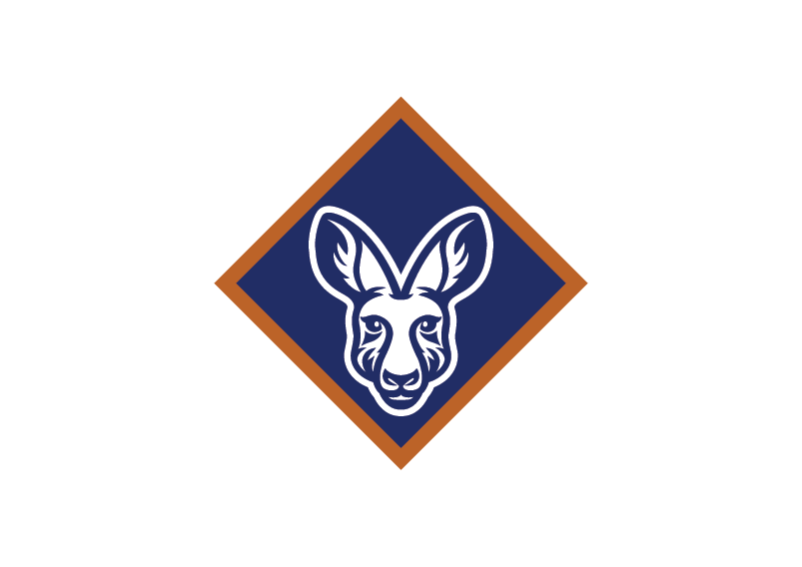
Cub Scout badges
Grey Wolf Award Leadership Course
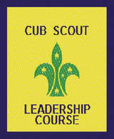
Bring a Friend badge Introduction to Section
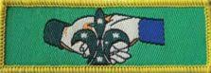 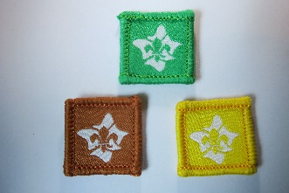 or similar badge
Scout badges
Australian Scout Award Leadership course
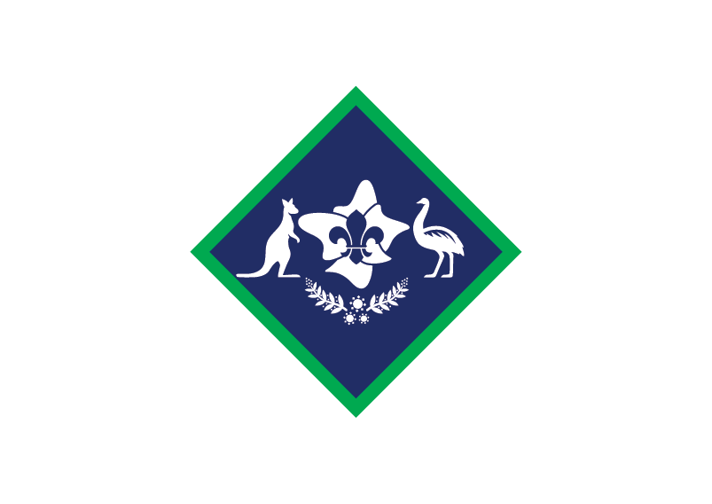 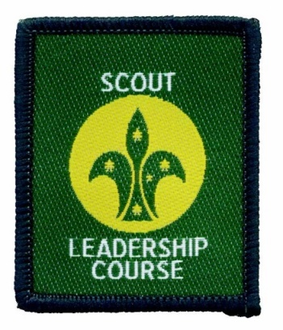 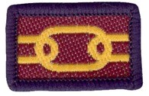 Introduction to Section or similar badge

Venturers Queen Scout Award
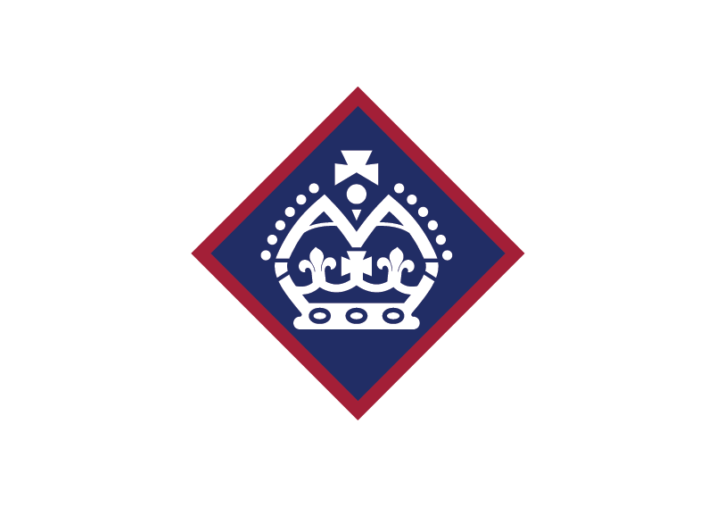
Rovers
tba

