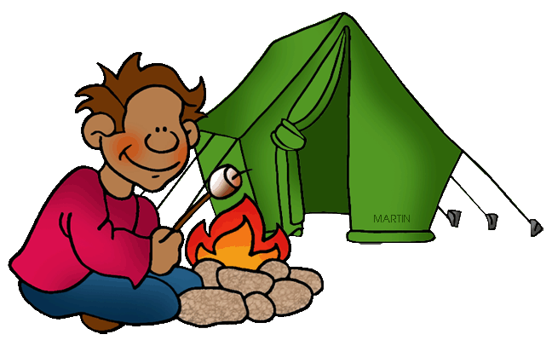

2 Days. Home Camp & online
1st Heights for Joeys, Cubs, Scouts, Venturers

- Everything is optional – Scouts can join in at any point, family camps are good to go
- When online, for security, Scouts should be wearing their uniform or at least the Group Scarf
- No printer ?. just make notes with paper and pens
- Plan your menu and shopping (see separate planning file Steps 1-7)
Day 1
10am camp starts Uniform & scarf
Online meeting. click on this Zoom link eg aaaaaaaaaannnnnnnnnn******……nnn
Or join in by mobile or text or just start
10.30am Set up your tent or shelter outside or camp inside but not on a bed.
Shelters can be a hike tent, family tent (invite the family for the weekend), tarp over a piece of rope between two trees, Indian tepee, tree house, sleep under the stars etc
Prepare your cooking area Check campsite safety and hygiene
12-1pm lunch
Make a seat, table, clothes line, hooks to hang tea towels, mugs
Take some photos of the camp. Post them on social media or group website
Start a log of what is happening on the camp see log below
3pm Afternoon tea. Invite the family. Call your relatives for a virtual afternoon tea

3.30 Scavenger hunt. One of the leaders will text or email a list of objects to find or make. Take a photo of the result

5pm Prepare for and have dinner. Invite the family, plan a game for after dinner
6pm Online meeting Click on this Zoom link eg aaaaaaaaaannnnnnnnnn******……nnn
Same link Invent a short game for playing online
8pm Supper Check out the sky and stars . It is the clearest you may every see.
What is the major constellation in your area ?

Day 2
7am Breakfast Then wash up and put eating gear away (mess kit, dilly bag)

8am Tidy your tent, bedding and clothes. Take a picture
Build a camp gateway, or flag pole, make a flag etc
Draw a picture of your camp and a mud map (details below )of the area for 50 meters around
10am Morning tea
Play a game, read a book relax
12 noon lunch
2pm closing parade Online meeting click on this link eg aaaaaaaaaannnnnnnnnn******……nnn Same link invent a short game for playing online
 |  | Camp Activity log Name=
Dates, Location, Times |  | What did you do or achieve, who went along, weather, equipment, comments. |  | Your role in activity. Participant, assist, lead,

1st Heights Scouts Online Camp Challenge
Participate in Online Camp and record your progress with photos or written logs.

Activity suggestions How many can you attempt? Keep them for when we meet at the hall
Set up a tent in your backyard without help. Be prepared to sleep out during Online Camp. | Do something memorable with your family.  e.g. Game night | Make a 20 second video of you washing your hands. | Design a coat of armour, flag or insignia to mark your campsite for Online Camp. | Write some messages of kindness for your neighbours. Deliver them on a short walk along your street.
Make a list of things you would take on a weekend camp. | Build a campfire suitable for cooking on.  Can you light it without a match/lighter? | Make a sock puppet and use it to create a puppet show video that you can share with the unit. Maybe the puppet could join you on a Zoom meeting | Try photography!  Take photos of everyday items at random angles and challenge others to identify them. Share them with the Unit. | Create a fitness challenge for you to practice every day. Document with some photos
Build something with ropes and sticks using 2 lashings.  e.g a gateway for your campsite | Plan a balanced meal for your family. Cook it on a camp stove or campfire. | Can you identify 3 other constellations in the night sky? Which ones were they? Draw what you see. | Build a bird feeder from a recycled bottle or carton.  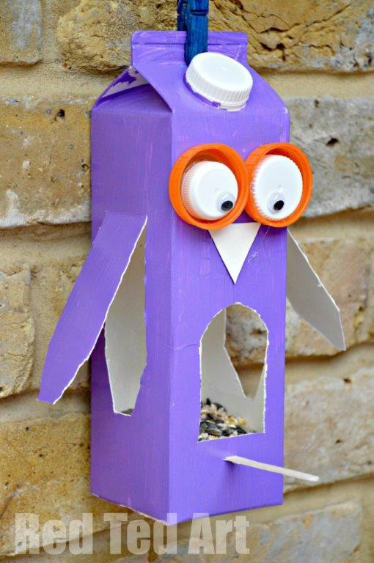
Choc hunt!  Hide 10 chocs, take a photo and share it with the Unit. | Make a shelter out of plastic sheeting, rope and other things you have found. Would you sleep in it? | Build something that doesn’t need ropes to construct.  Look up a ‘friction bridge’ | What’s the weather forecast for Online Camp? Where did you find this information? | Identify the Southern Cross. Which way is south?  Take a photo if possible

Making mud maps
For 1000s of years land explorers have been making rough maps to see where they are going & where they have been. When first out exploring they made lines in the mud with a stick and then drew what they had seen on paper etc.
Baden Powell made them in the army and continued when in scouts.
Scouts and leaders have continued the idea for over 100 years.
Now it is your chance to map your area and your favourite walks.
Hand draw a map with details from around your house & then expand to local parks and walks.
These maps can be for your benefit & to show the next group of scouts.
For lots of examples just Google "drawing hand mud maps”

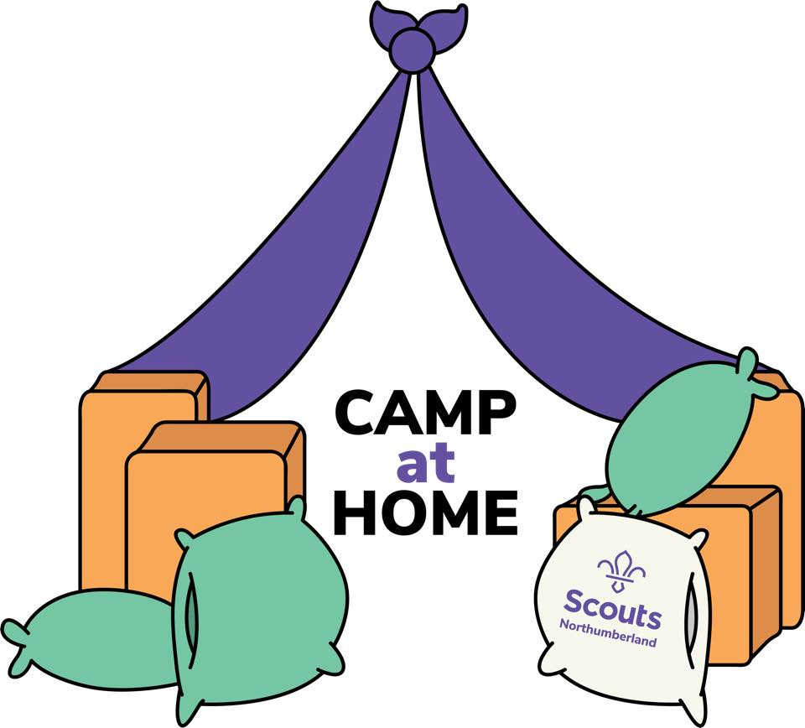

Certificate of participation

Virtual camp at home due to Corvid 19 Pandemic 2020
Dates………………
Name………………
Section…………….
Group………………

Northumberland Scouts facebook https://www.facebook.com/NorthumberlandScouts/?tn-str=k*F

Thanks to all those who contributed to this virtual activity

