Community Helping, assisting, visiting, donating, making, repairing, planting, fundraising, investigating, learning, meeting, understanding.
Oz suggestions. Highlight the ones that suit your Joeys, Cubs, Scouts, Venturers, Rovers.
- War memorial clean up
- Anzac Day march
- Australia day Flag ceremony. Join or be the Colour party with the flags
- Citizenship ceremonies by the local Council. They often invite patrol to seat guests, hand out small trees to the new Australians
- Visit local Council meeting Get an Invite from local councillor
- Bushcare. planting and maintenance of local grounds
- Clean and regenerate local creeks and reserves.
- Clean up Australia day. Anywhere
- 1st August National Tree Day. Link up with your local scout camp or council rangers.
- Fundraising for charities. Car wash, donations, maintenance, discover who they help.
- Scout camp maintenance. Painting, weeding, cleaning.
- Donate tinned food, toys etc to local charities.
- Visit RSPCA, animal shelters. Donate items, walk the dogs, clean the grounds
- Organise a maintenance day at a local scout hall that needs help
- Find out how Meals on Wheels works, how can you help
- Fundraise & donate to charity looking after the homeless. Discuss the problems.
- Nursing homes & hospitals. Arrange a visit, play bingo, make up cards, cook some cakes. Visit at Christmas and sing Carols and hand out Xmas cards to staff and patients. Instead of performing for the residents, you can sit and talk with them. They have lots of great stories, and you can share your own stories, too!
- Take your Cub Scouts to a local nursing home to play bingo. The Scouts can take turns being the caller while the other kids pair up with players
- Visits to and from emergency services. Police, ambulance, SES, Rural Fire, Paramedics
- Citizen Scientist. Check the website for all the things you can do.
- Visit observatory
- Schools. Run a scout base at the school fete or fun day. Organise and help out at a working bee. Run a BBQ at a working bee.
- Fun Runs. Help at the water bases and finish points.
- Visit or invite local indigenous members to tell you the history of the land
- Religious organisations. Invite Elders to tell you about their faith
- Other nationalities. Invite members fro ethnic groups to join you at the hall or visit them at their hall
- Neighbours. Check out your street and talk to neighbours who might like some gardening etc
- Red Cross blood donation (to them !)
One study found that “volunteering is also associated with the development of greater respect for others, leadership skills, and an understanding of citizenship that can carry over into adulthood.”
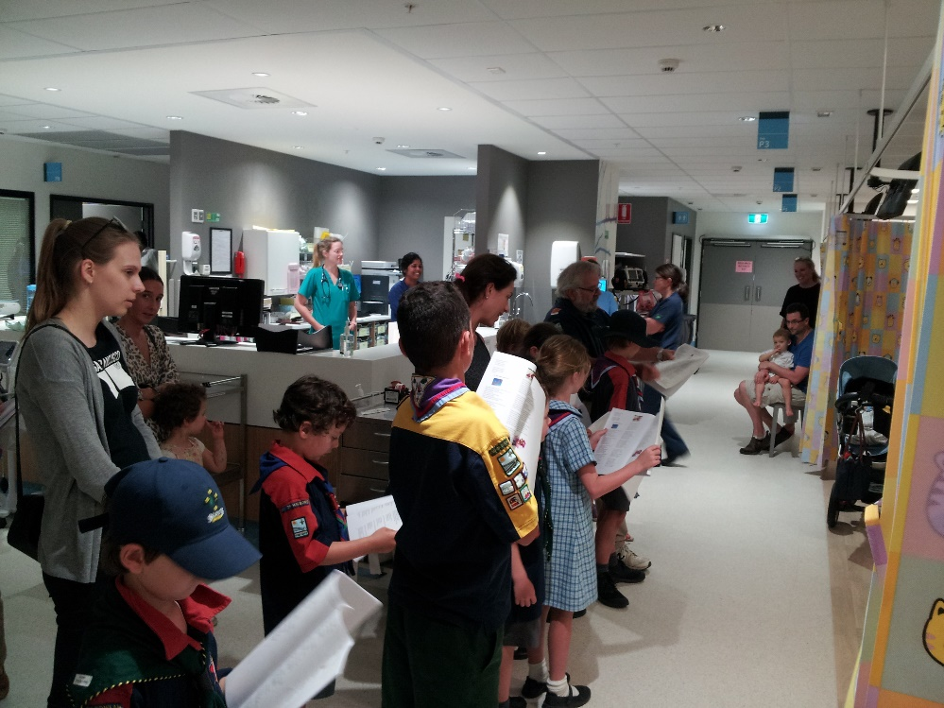
Other suggestions
- Pick up litter at a park. This is twice as cool if it’s a park you already enjoy. That way, you can give back to a place that gives you so much!
- Put together a book drive for a local children’s shelter. Help kids like you have access to books you love.
- Write thank you notes to local fire and police stations. You can thank them for keeping your city safe!
- Plant trees or wildflowers. For this one, make sure you work with an adult to get your town’s OK to plant anything on public grounds.
- Perform magic tricks at a retirement center. You can show off sleight of hand
- Collect old eyeglasses and donate them to an organization that recycles them. You can help make sure people who really need glasses can afford them.
- Collect non-perishable food items. You can participate in a drive
- Collect items like old towels, blankets and unopened pet food to donate to animal shelters. The kitties and pups will thank you!
- Collect items for a time capsule. You can work with an adult or older Scout
- Write greeting cards for a local nursing home. You can even write birthday cards and ask someone who works at the nursing home to distribute the cards on the seniors’ birthdays.
- Develop and maintain a recycling program at school. This is a great way to be a leader at school, meet new teachers and make new friends who can help you.
- Donate clothing and toys to the needy. A lot of shelters for people in need rely on year-round donations. Work with an adult to find the right place to share the things you’ve hardly used and no longer need.
- Write holiday cards, birthday cards, and notes for assisted living facilities, children’s hospital wards or Meals on Wheels. Some people don’t hear from anyone on holidays. You can change that. Think critically and consider holidays you don’t always think about. For instance, you can send Passover cards to a Jewish assisted-living facility. Or you can send a thank you card to a veteran who receives Meal on Wheels on Veterans’ Day.

- Volunteer to walk dogs at a local animal shelter.
- Check with your local Ronald McDonald House to see if they accept donations of pull tabs from soft drink cans. If they do, have the Scouts organize a pull tab drive.

- Make treats and take them to your fire or police department. Call ahead, and ask if you can tour the department while you're there.

- Help clean up after a community event
- Write thank you letters to your Cub leader and Committee Chairperson. Invite them to your next den meeting so that the Cub Scouts can present them with the letters.
- Organize a sock drive for homeless shelters. Socks are one of the most needed yet least donated items at a homeless shelter. we donated the socks to a homeless shelter for teens.

- Pick up trash, but make it a fun scavenger hunt.
- Make birthday cards to give to the seniors. Contact a local nursing home about starting a birthday card program

- Collect gently used stuffed animals to donate to the fire or police department. They often give them to kids in emergency situations.
- Identify a local organization that can benefit from donations of gently used books and organize a book drive.

- Clean out and replant the flower beds at the organization's location.

- Team up with your local Lions Club to collect old pairs of eyeglasses for needy folks.

- Gather supplies to make birthday bags to donate to your local food pantry. Decorate the bags and include cake mix, frosting, candles, and even a small gift.

Great Scout service project ideas BSA

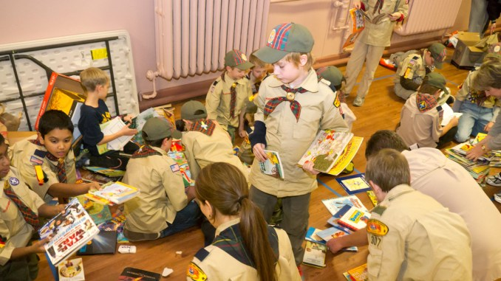
Nothing your Scout unit can do raises community awareness more than a service project. These good turns are some of our best marketing tools. They send the message that Scouts are here, making life better for others.
By Bryan Wendell Cub Scouts BSA says on line I’ve collected Scout service projects below.
- Organize a book and magazine drive, with the collected items going to a daycare, overseas soldiers, a VA medical center or an inner-city school
- Improve your local Scout camp, perhaps by clearing trails, splitting wood, repairing tents or more
- Volunteer at a district event, running the first-aid station
- Participate in Scouting for Food, the annual canned-food drive
- Go Xmas carolling at a local nursing home
- Perform skits or songs at a homeless shelter, nursing home or children’s center
- Collect gifts and make gift baskets for elderly people with no families
- Prepare and distribute holiday cards (Valentine’s Day, Christmas, etc.) for people without families of their own
- Assist in snow/ice removal for members of the community or businesses that need a hand
- Assist in yard work for members of the community or businesses that need a hand
- Adopt a needy family
- Help agencies cook and serve meals for the homeless
- Make gift boxes to be distributed by a local charity
- Stock shelves at a local food pantry
- Deliver, retrieve and dispose of Christmas trees
- Help residents set up or take down Christmas lights
- Collect toys for a local charity
- Purchase and distribute toys for the children’s hospital near you
- Make stuffed animals to brighten up a child’s holidays
- Assemble Easter baskets and distribute to local shelters
- Provide free coffee at rest stops on heavy travel weekends
- Create or help create and run a haunted house
- Assist at alternative trick-or-treat events
- Adopt a town after a disaster
- Assist organizations that provide home maintenance service
- Help paint, repair a school, church or organization
- Clean a local animal shelter Help walk the dogs at the animal shelter
- Perform janitorial duties for a local organization
- Repaint fences at government or non-profit buildings
- Adopt a Highway or road or park and take care of it
- Take part in a litter clean-up project
- Clean up and/or help inventory a cemetery
- Clean up & beautify the local community centre, campground, park, river, school parking lot
- Clear brush from a fire-prone area local or Scout camp
- Improve a town walking trail
- Help package medical supplies to be sent to developing countries
- Distribute organ donor cards. Rovers
- Pass out anti-drug literature
- Provide the first-aid station at a district or council event
- Create and distribute first-aid kits to residents in need
- Help children make bicycle safety kits
- Make welcome-home kits for victims of a disaster
- Make bandanas, pillows or other items for cancer patients
- Serve as “victims” for a local first-responders training event
- Become pen pal with someone serving overseas
- Organize a movie night for someone
- Assist in training search and rescue dogs
- Clean and refill bird feeders at the local aviary
- Collect aluminium cans and donate the proceeds to a local charity
- Construct duck houses, owl boxes or birdhouses
- Build a fence around air conditioners at a local establishment
- Conduct a CPR training event
- Build a handicap ramp at a community location
- Run a basketball tournament
- Volunteer at the Special Olympics — water station, handing out medals, etc.
- Construct a soccer field: lines, goals, benches
- Construct bat and helmet racks for your school’s baseball/softball teams
- Host a dodgeball tournament and donate the proceeds
- Serve as volunteer referees or umpires at a sports tournament
- Set up and help run a website or Facebook page for your organization or a local nonprofit
- Perform at a local charity talent show
- Create a poison awareness campaign
- Paint over graffiti (but first check with your city/town government)
- Sponsor a TV blackout event to encourage families to spend time outside
- Host a free camping clinic where you share basic camping skills with residents
- Plant, tend and harvest a vegetable garden and donate what you grow
- Organize a pet show, with a portion of the proceeds going to the winning dogs and the rest going to a local charity
- Design placemats for Meals on Wheels recipients
- Rake leaves for elderly neighbour’s and tidy gardens

