From Scout Australia facebook 25.3.20
Last night 1st Doncaster Cubs 2nd pack held an online meeting.
We had a fantastic turnout of 14 cubs & 4 leaders.

We held a pack council and then had fun with a scavenger hunt.
Zoom was used on a variety of devices and everyone agreed it was a very successful trial for our future nights - so much so that the cubs have asked if we can continue it during the holidays!!!

If anyone is worried about going online - don’t be. The cubs embraced it and I have already had parents email thanking me.

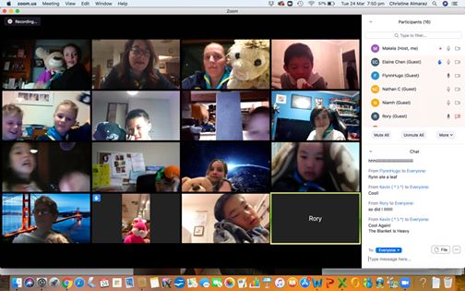

I didn’t do a program as it was really a test to see if it would work.

Started with a pack council - ideas, what next

Then I did a scavenger hunt. Would call out things they had to find, then come back for the next one.

Basically so they weren’t just sitting down the whole session.
Finished with a few games of hangman from the online whiteboard.
Worked out I can share my screen at the end.

Christine

