**CUB SCOUT BOOMERANG CHALLENGE**

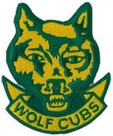

**Akela**

**Email =**



#. Post a video of you washing your hands, (on the Group’s FB page)

or send me pics of you trying

Have you tried the rubber glove and black paint technique? See video on

<https://sydneynorthregionscoutsresources.weebly.com/>

Discuss why hand washing is important.

#. list what should be in your first aid kit.

........................................................................................................................................................

........................................................................................................................................................

# Make your breakfast, take a photo and send it to Akela,

Make sure you have left the kitchen clean afterwards

What did you have? And how did you make it

........................................................................................................................................................

..................................................................................................................................................................................

..................................................................................................................................................................................

# Make a list of possible dangers in your house.

........................................................................................................................................................

........................................................................................................................................................

........................................................................................................................................................

........................................................................................................................................................

#. Explain the Buddy System

.......................................................................................................................................................

........................................................................................................................................................

ROPES

Grab some rope and practice

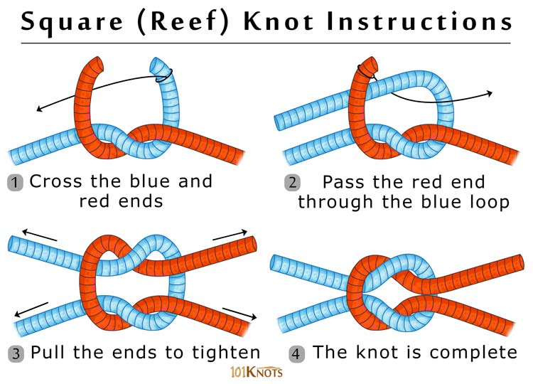

Where is the most common place a reef knot is used?

........................................................................................

**Can you tie your shoelaces? now is the time to practice**

**Send Akela a pic of you trying.**

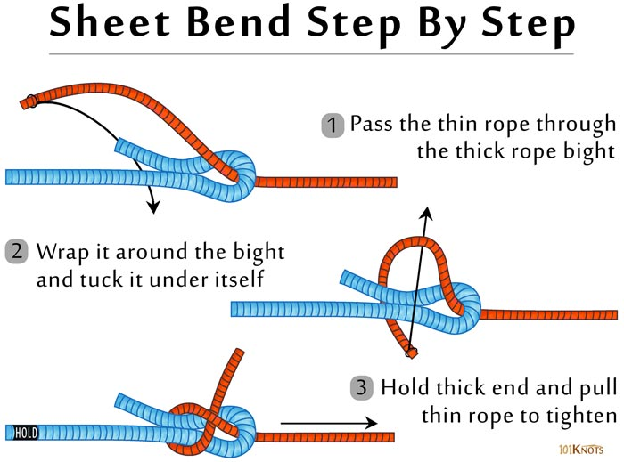

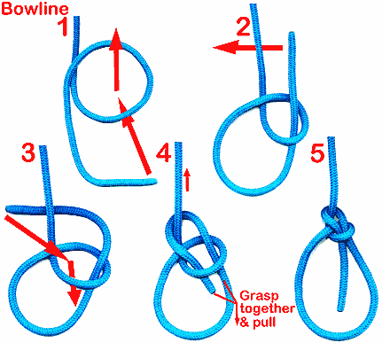

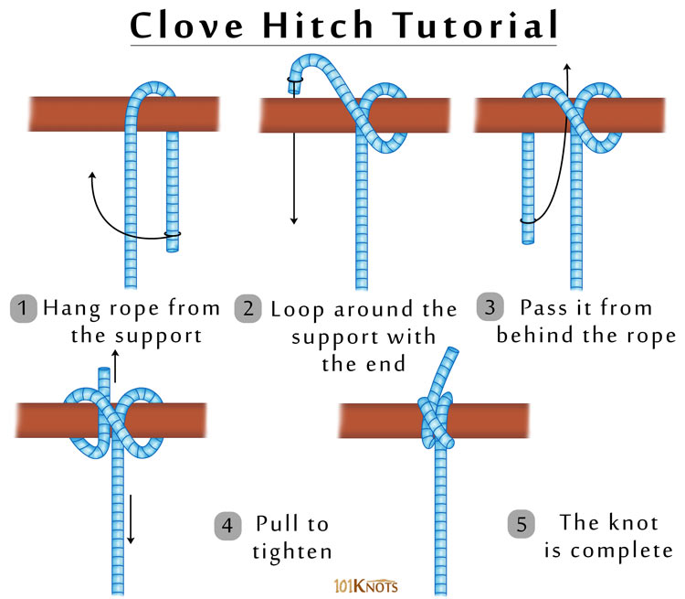

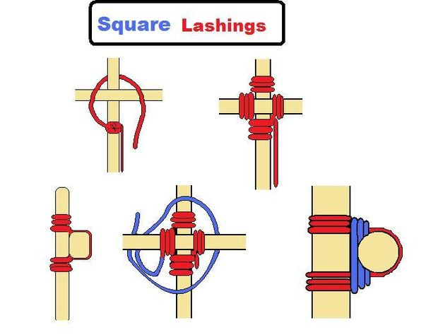



OUTDOOR SCOUTING

MAKE A COMPASS, USING A CORK AND A NEEDLE. CAN YOU DO IT ??

WRITE AN EXPLANATION OF WHAT YOU DID AND HOW IT WORKS

Type this into Google for ideas ”make a compass from magnet and needle at home”

..................................................................................................................................................................................

..................................................................................................................................................................................

..................................................................................................................................................................................

..................................................................................................................................................................................

DRAW A COMPASS WITH 8 POINTS N,S,E,W, NE,SW,NW,SE,

Download a compass app

**JUNGLE BOOK**

WRITE A SHORT STORY ABOUT A CHARACTER FROM THE BOOK.

Check out the books by Rudyard Kipling on

[https://study.com/academy/lesson/summary-of-the-jungle-book-by-rudyard kipling.html](https://study.com/academy/lesson/summary-of-the-jungle-book-by-rudyard%20kipling.html)

..................................................................................................................................................................................

..................................................................................................................................................................................

..................................................................................................................................................................................

..................................................................................................................................................................................

..................................................................................................................................................................................

..................................................................................................................................................................................

..................................................................................................................................................................................

..................................................................................................................................................................................

..................................................................................................................................................................................

**WHEN DID SCOUTING START IN AUSTRALIA?**

DO SOME RESEARCH AND FIND OUT WHERE THE FIRST SCOUT GROUP WAS FORMED.

WRITE SOME INTERESTING FACTS ABOUT SCOUTING IN AUSTRALIA. FAMOUS AUSTRALIAN SCOUTS!

..................................................................................................................................................................................

..................................................................................................................................................................................

..................................................................................................................................................................................

..................................................................................................................................................................................

..................................................................................................................................................................................

..................................................................................................................................................................................

..................................................................................................................................................................................

..................................................................................................................................................................................

..................................................................................................................................................................................



**DRAW THE AUSTRALIAN FLAG**

**DRAW THE AUSTRALIAN COAT OF ARMS.**

Name a place this can be found. ..............................................................................................................

 **DO A GOOD TURN**

what does this mean?

Tick off the Jobs when done, you can do them more than once. This chart is for a week

|  |  |  |
| --- | --- | --- |
| CHORE | POINTS | TICK WHEN DONE |
| Unpack your school bag | 5 |  |
| Unpack the dishwasher | 20 |  |
| Put your clothes away | 20 |  |
| Feed the pets | 10 |  |
| Clean Bedroom | 50 |  |
| Take out the rubbish | 20 |  |
| Make your bed | 20 |  |
| Read a book | 20 |  |
| Clean up the toys | 100 |  |
| Vacuum the lounge | 30 |  |
| Hangout the washing | 100 |  |
| Help cook Dinner | 50 |  |
| Help a sibling with a job | 100 |  |
| TOTAL |  |  |

**THE SCOUT PROMISE**

**FIND A WORD WORDS TO FIND**

**E M L Y N C E D P N I B A E A AND**

**N V T T S E B E S I I K S S I AUSTRALIA**

**M U I I C A O U F K L P O I L BEST**

**D G P L L P R D E Y O W H M A DUTY**

**D R K E L G L F V H G O P O R GOD**

**R D Y E L G E Q F E P M C R T HELP**

**C L V T L N Y R V L P P O P S HONOR**

**C R O N O H E N E P Q E B H U LAW**

**S U P M F E S E A H V U J Z A LIVE**

**C J X V P A H X U M T V U G Q OTHER**

**O F H D C R S T S Q C O D N A PEOPLE**

**U S P E P V Q I S B L A W Q K PROMISE**

**T H Z B A D T J M G O D W O A QUEEN**

**F Q I N R U L P G S B B O D H SCOUT**

**J Y L C U H Q Z W A B H S I P** **THE**

**WRITE THE SCOUT PROMISE Check on**  <https://scouts.com.au/about/what-is-scouting/promise-law/>

**.......................................................................................**

......................................................................................................

......................................................................................................

**SCOUTS OWN**

What is this?

Write a small thought of what you think this is and why we often have one on camp

........................................................................................................................................................

..................................................................................................................................................................................

..................................................................................................................................................................................

..................................................................................................................................................................................

..................................................................................................................................................................................

**CRAFT**

Do something creative,

here are some ideas

Make a puppet

Make a clay pot

Paint a picture

Learn to Knit

Learn to sew

Make a musical Instrument

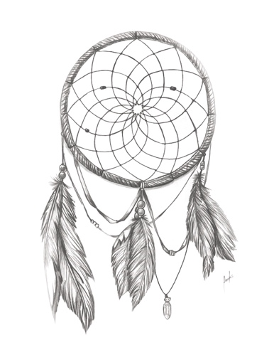Make a dream catcher

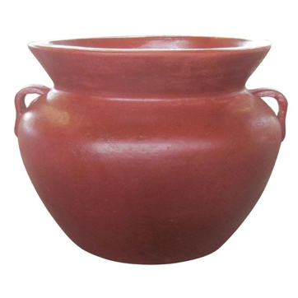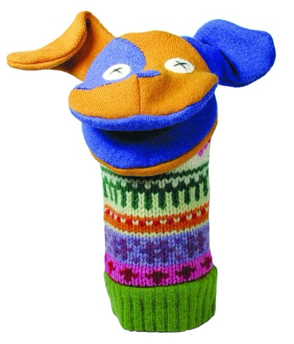



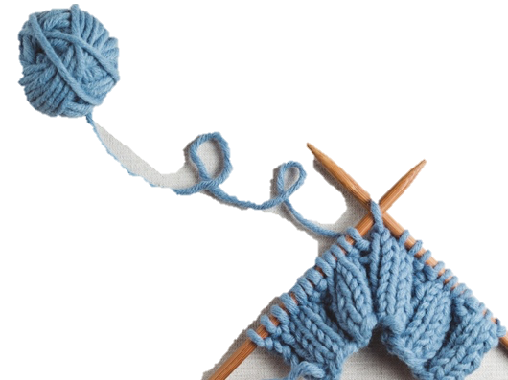

**LITRATURE CHALLENGE**

List 10 books you have read over the holidays

1......................................................................................................................................................

2................................................................................................................................................................................

3................................................................................................................................................................................

4................................................................................................................................................................................

5................................................................................................................................................................................

6...............................................................................................................................................................................

7......................................................................................................................................................

8......................................................................................................................................................

9.....................................................................................................................................................

10....................................................................................................................................................

Write an alternative ending for one of these books

........................................................................................................................................................

..................................................................................................................................................................................

..................................................................................................................................................................................

..................................................................................................................................................................................

..................................................................................................................................................................................

..................................................................................................................................................................................

........................................................................................................................................................

..................................................................................................................................................................................

..................................................................................................................................................................................

..................................................................................................................................................................................

 **ENVIROMENT**

RECYCLE SOME RUBBISH AND MAKE A TOY.

TAKE A PICTURE AND DESCRIBE HOW YOU MADE IT

**..............................................................**

**..............................................................**

**..............................................................**

**..............................................................**

**..............................................................**

**GROW A GARDEN**

USE AN EGG CARTON AND START A HERB GARDEN

WHAT DID YOU PLANT?

DID IT GROW?

KEEP A WEEKLY RECORD OF ITS PROGRESS.

..............................................................

..............................................................

..............................................................

..............................................................

..............................................................

**ENGINEERS CHALLENGE**

Design a machine with moving parts and power source.

Explain the function of the moving parts and how they work as an integrated unit.

#. List 2 engineering discoveries which, in your opinion, **have been of benefit to mankind.**

Explain your opinion and any evidence you have found and the reasons for your conclusions.

..................................................................................................................................................................................

..................................................................................................................................................................................

..................................................................................................................................................................................

..................................................................................................................................................................................

..................................................................................................................................................................................

..................................................................................................................................................................................

..................................................................................................................................................................................

..................................................................................................................................................................................

..................................................................................................................................................................................

..................................................................................................................................................................................

.................................................................................................................................................................................

#. List 2 engineering discoveries which, in your opinion, **have been harmful to mankind.**

Explain your opinion and any evidence you have found and the reasons for your conclusions.

..................................................................................................................................................................................

..................................................................................................................................................................................

..................................................................................................................................................................................

..................................................................................................................................................................................

..................................................................................................................................................................................

..................................................................................................................................................................................

..................................................................................................................................................................................

..................................................................................................................................................................................

..................................................................................................................................................................................

..................................................................................................................................................................................

..................................................................................................................................................................................



**SCIENTIST**

Perform an experiment that shows a chemical reaction

Take some photos.



**I.T.**

SEND AKELA AN EMAIL WITH ALL YOUR ACHIEVEMENTS

LET ME KNOW WHAT YOU HAVE BEEN DOING.

READ YOUR YELLOW BOOK.

FIND SOMETHING ELSE YOU CAN DO .

HAVE YOU TRIED MORSE CODE OR AUSLAN?

Come up with an idea we can all do over the internet.

Let me know your ideas.

How can we have a pack council?

Would Zoom work ?