Ingleside Scouts invite you to go flying with them

No previous experience required !

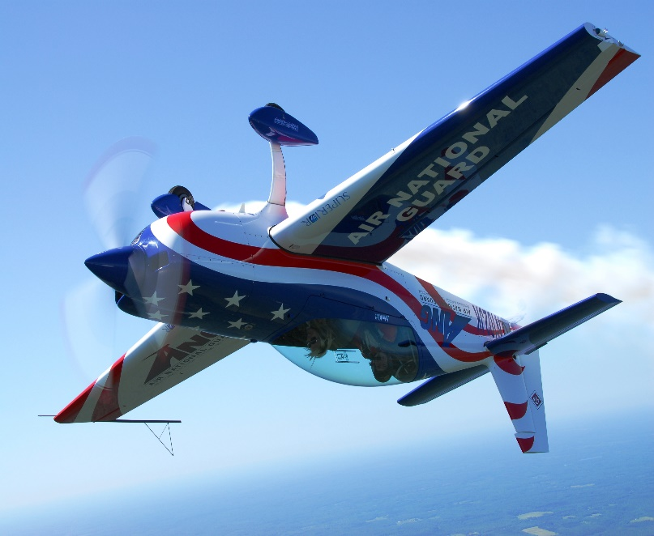

We are going to the scout Flying base at Camden

n

