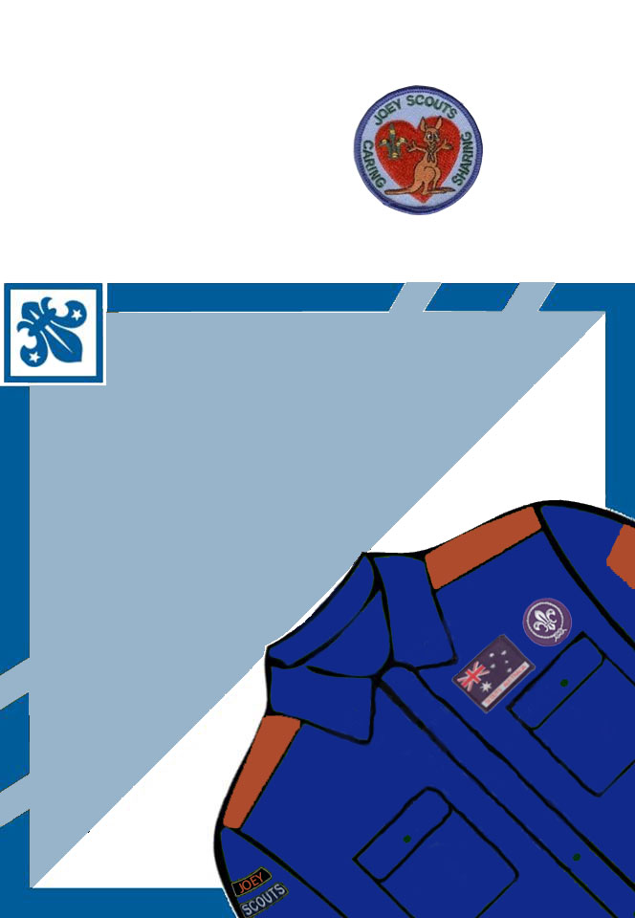

FREE

INVITATION

Tuesday 19 & 26 July 2

14 Hand\*\*d St Eltham

6.00 - 7.30

rsvp Wayne 0413 173 \*\*\*  
or your friend

26 July

Damper

Billy Tea

Apple Peeling

2 August

Bear Grylls Survival Bracelets

9 August

Bonus Night

INVITATION  
from Mitchell  
to Come  
and try  
Scouting