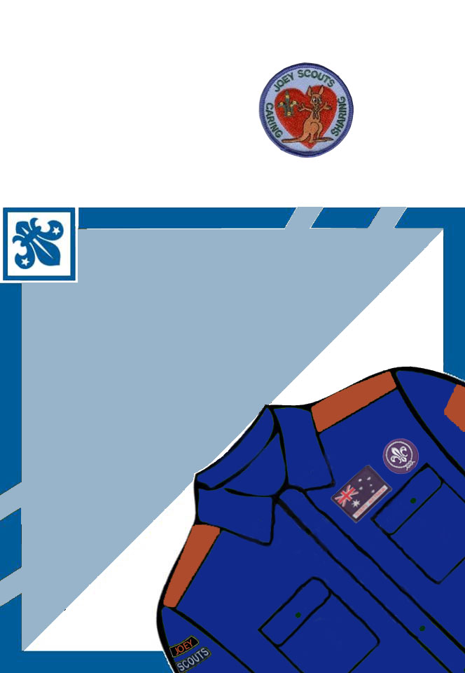
FREE
INVITATION
Tuesday 19 & 26 July 2
14 Hand**d St Eltham
6.00 - 7.30
rsvp Wayne 0413 173 ***
or your friend
26 July
Damper
Billy Tea
Apple Peeling

2 August
Bear Grylls Survival Bracelets

9 August
Bonus Night
INVITATION
from Mitchell
to Come
and try
Scouting

To alter the wording just put the curser over the text and click. Then put in your own details. When ready, print the page above and fold across the centre and fold down the wings. You can cut off the top of the square if you want to or the scouts can write other details on it and it can be part of the invitation.
Original Sample
