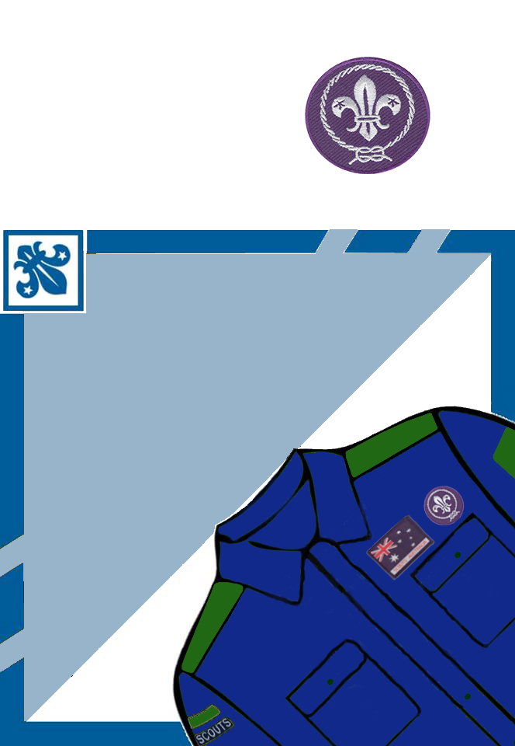
FREE NIGHTS
INVITATION
Tuesday 2, 9, 22 & 23 May
14 Handy St, Elsom
6.00 - 7.30
rsvp Wayne 0406 123 987
or just turn up any night

2 May
Bushcraft

9 May
An In-Tents Challenge
16 & 23 May
Bonus Nights

INVITATION
from Peter
to Come
and try
Scouting

To alter the wording just put the curser over the text and click. Then put in your own details. When ready, print the page above and fold across the centre and fold down the wings. You can cut off the top of the square if you want to or the scouts can write other details on it and it can be part of the invitation.
Original Sample
