Our 1st online session with joeys.
Opening parade- salute paper flag, law
Games- Rock, scissors, paper. good/ bad hygiene habits;
Craft- make a simple accordion fan.
Mob council- joeys ideas to do together on line next term
Song- A Ram sam sam
Closing parade- salute flag, prayer
Home activity till next meeting-
a) draw jungle theme pictures onto fan and put picture on our fb;
b) video joey washing hands 20 secs singing a song at top of lungs, and put on our fb.
Worked very well.

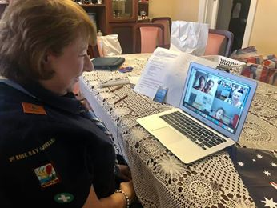

Thanks, Shirley

