[Name]’s path to Joeys Challenge Award

Joeys Challenge Award is the highest award Joeys can achieve. It represents your hard work and dedication to Scouting in the Joeys section. Based on your time remaining in section and your progress so far, you are a candidate for Joeys Challenge Award. Completing this award is optional, however all the awards and achievements listed here are open to you whether you choose to work toward your Joeys Challenge or not.

Milestone 3

You need:

X Assists
X Leads

Core Outdoor Adventure Skills

You need to do the challenges below :

Bushwalking Stage 1

I can help pack a backpack for a day walk
I can dress myself for a day walk
I can list what food to bring on a day bushwalk
I know why it is important to stick to trails when outdoors
I know why to stop when I get lost in the bush
I can explain the buddy system
I can put together a small personal first aid kit for our bushwalk
I can identify the four main cardinal points on a compass
I can identify the main parts of the compass
I have attended at least one bushwalk of at least one hour’s duration at this stage
I can demonstrate behaving safely while bushwalking

Bushcraft Stage 1
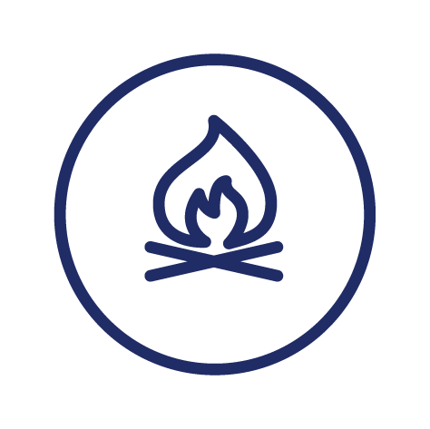

I know why it is important to stick to trails when outdoors
I know about the “Buddy” system
I know to stop when I get lost on activities
I know my address and location in an emergency
I know three reasons for having a shelter when sleeping outdoors
I can strike a match
I can collect sticks for preparing a campfire
I can be safe around a campfire
I have participated in a game that required basic navigational skills
I can hang a clothesline at camp with a clove hitch or other knot
I know how to correctly pack ropes away
I know what is in a dilly bag/mess kit and can keep it clean at camp

Camping Stage 1

I know about the buddy system
I know the boundaries of where I may go each time I go out camping
I know to stop when I get lost while camping
I know the basic elements that you need to make a fire
I know that I should follow directions from the leader of this activity
I can help pack a bag for camp
I can strike a match
I can help prepare food for cooking at camp
I have spent two nights at camps and/or Scout sleepovers
I know why it is important to set up camp in an existing campsite
I can set out my sleeping area at camp
I can care for my basic personal gear on an overnight camp

Special Interest Areas
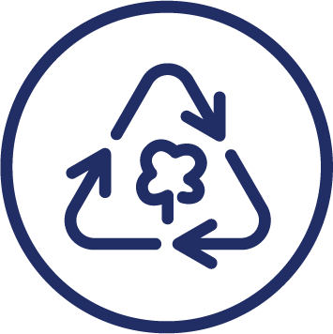
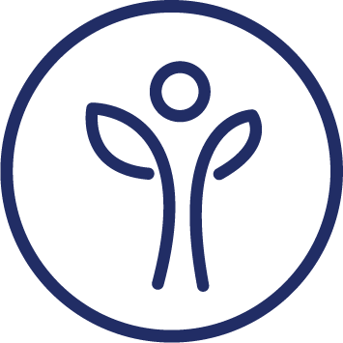

You need:

X more SIA awards in at least X areas (Adventure and Sport, Arts and Literature, Creating a Better World, Environment, Growth and Development, STEM and Innovation) – aim for approximately X completed per [period]

Adventurous Journey

Plan and participate in a 3 hour journey with your Project Patrol or Unit

Personal Reflection

The last thing you should do for your Peak Award. You could document this using a record book, maps, photographs, videos or al of these, or just tell a story about your experiences to your Unit.

Your link up to Cubs: After your 8th birthday, during or after [month] as discussed with your leaders

