Milestone Challenges 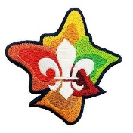
Some ideas
Community | Creative | Outdoors | Personal Growth
Getting out in the community Engagement Involvement Projects & Partnerships  Visits Volunteering Diversity & Inclusion Environment Active citizenship | Expression Arts  Making Creating Inventing Designing Planning | Environment Camping  Time in nature Water activities Adventurous activities Journeys | Health & Wellbeing Resilience Mental health Beliefs & Values  Social justice Skills  Interests
Local  National International Supporting Knowledge Service | Unusual  New  Colourful  Bold Innovative Investigative | Fast  High  Wide  Slow  Deep  Safe | Individual Healthy Growing Believing Commitment Understanding New skills
Inclusive | Challenging | Fun | Adventurous

