1. Iron & roll the edge several times until you get midway up the scarf

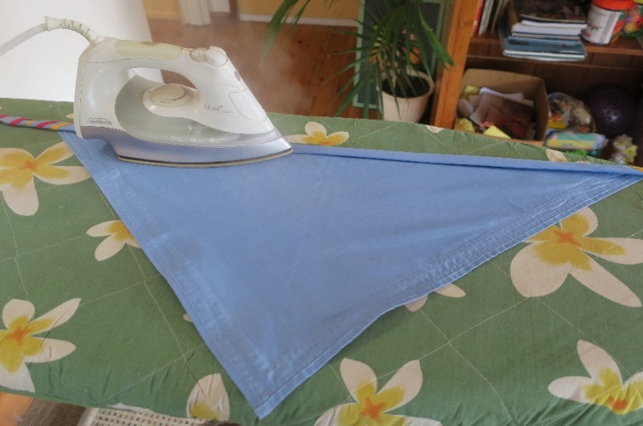

2. Roll the second half with fingers at each edge

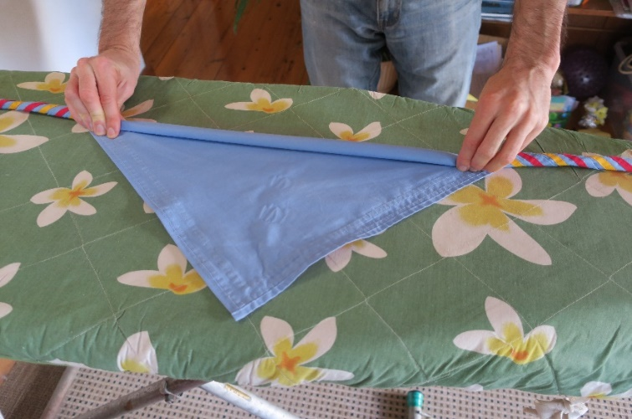

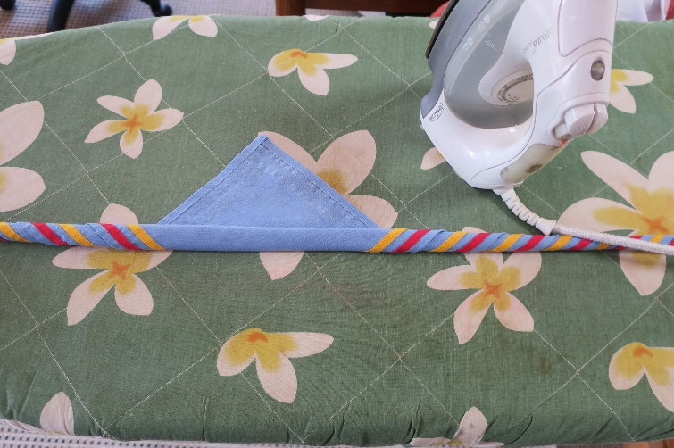

3. Sew the edge on both sides of the triangle
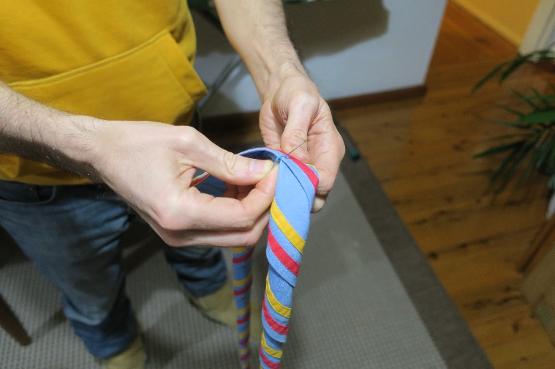

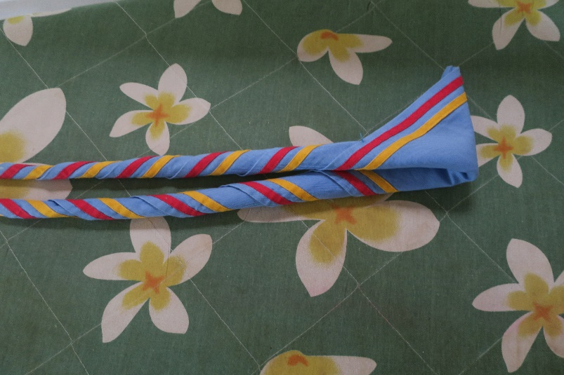

Ready to go for months without falling apart
When time to wash just cut the sewing
Write your name with biro on the inside edge

After opening parade scouts can put their scarf in a plastic patrol box with their Record books
This way the scarves are kept neat and clean and no lost woggles

