Around the House Scavenger Hunt
- Something Blue
- Something with a nose
- Something to sit on
- Something round
- Something with wheels
- Something you can eat
- Something to write with
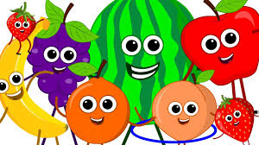
- Something made of plastic
- Something that lights up
- Something that makes a noise
- Something to eat with
- Something that floats
- Something orange
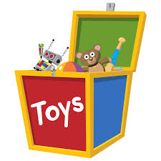
- Something that feels rough
- Something with a pattern.
- Something that opens
- Something you can wear
- Something fluffy
- Something you can build with
- Something red

