- Participate in a Driveway ANZAC Service on 25th April

- Bake ANZAC Biscuits

- What is ANZAC Day?

- Make a Poppy Wreath & Poppy Lantern

- ANZAC Word Search
Joey Scouts
Their Service Our Heritage
Activity Pack

Please remember to take photos of your Joey participating in these activities so that they can be awarded the Their Service Our Heritage Badge. Photos can be shared in our Facebook Group or emailed to the leaders.

If anyone needs this Activity Pack printed off or if you need help getting the resources needed to complete the activities please let us know and we can organise a contactless drop off/pick up.

Participate in a Driveway ANZAC Service on 25th April

Plan> Set your alarm for 5:30am so that you are up in time ready for a 6am start
Have your Joey Uniform cleaned and ironed ready to put on
Ask your parents to download “The Last Post” to listen to at 6am (there is supposed to be a broadcast on ABC – We will try and find a link to share on the Facebook Group)
Do> Get up and get dressed in your uniform
Stand on your driveway with your family
Have your Poppy Lanterns (see Activity 4) with you and candle lit (with parents help)
Ask you parents to play “The Last Post”
Review> Were you up and ready on time?
Did you stay quiet for the Minute Silence?
How did the driveway service experience make you feel?

Due to ANZAC Services being cancelled across the country due to COVID-19, there has been an idea circulating for the Australian Public to participate in a Driveway Dawn Service at 6am on Sat 25th April 2020. We would love for your Joey to participate in a service

- Have your Joey Uniform clean, ironed and ready to go . Please wear any medals that you may have from Grandparents.
- Get up at 5:30am, get dressed and head out to your driveway
- Have your Poppy Lantern (Activity 4) ready and light the candle
- At 6am, recite the Ode below and play “The Last Post”
- Observe a minute silence – reflecting on what ANZAC means to you
- Place your Poppy Wreath (Activity 4) at your letterbox, take a step back and salute.

The Ode:
They shall grow not old, as we that are left grow old:
Age shall not weary them, nor the years condemn.
At the going down of the sun and in the morning
We will remember them.
Lest We Forget

Parents: Please take photos of your Joey in their uniform participating in the service and laying their wreath. Photos can be shared in the Facebook Group or emailed to your leader

Bake ANZAC Biscuits
(Make sure you have an adult helping you!)

Plan> Have your recipe ready to go.
Measure out all your ingredients
Turn the oven on the pre-heat
Do> Follow the recipe and make your biscuits
Review> What worked well?
Did they taste good?
Was there anything that you would do differently?

Australian Womens Weekly
The Best ANZAC Biscuit of all time
Ingredients:
125 grams butter, chopped
2 tablespoons golden syrup or treacle
½ teaspoon bicarbonate of soda (baking soda)
2 tablespoons boiling water
1 cup (90g) rolled oats
1 cup (150g) plain flour
1 cup (220g) firmly packed brown sugar
¾ cup (60g) desiccated coconut

Method:

Preheat oven to 180°C/350°F. Grease two large oven trays; line with baking paper.

Stir butter and syrup in a medium saucepan over low heat until smooth. Stir in combined soda and the water, then remaining ingredients.

Roll level tablespoons of mixture into balls; place 5cm (2in) apart on lined trays, then flatten slightly.

Bake for 12 minutes or until golden. Cool biscuits on trays

What is ANZAC Day?

Visit the Australian War Memorial Website: https://www.awm.gov.au/commemoration/anzac-day/traditions

What is ANZAC DAY?___________________________________________________________________________

_______________________________________________________________________________________________

_______________________________________________________________________________________________

What does ANZAC stand for? ___________________________________________________________________

______________________________________________________________________________________________

______________________________________________________________________________________________

Have a look at the Virtual Galleries at the Australian War Memorial in Canberra by clicking on this link:
https://www.awm.gov.au/learn/learning-from-home/virtualvisit

What Virtual Galleries did you look at?
- ________________________________________________________________________________________
- ________________________________________________________________________________________
- ________________________________________________________________________________________
- ________________________________________________________________________________________
- ________________________________________________________________________________________
- ________________________________________________________________________________________
- ________________________________________________________________________________________
- ________________________________________________________________________________________

Which Virtual Gallery did you like the best? ________________________________________________________

What else did you find on the Australian War Memorial Website that you found interesting?
______________________________________________________________________________________________

______________________________________________________________________________________________

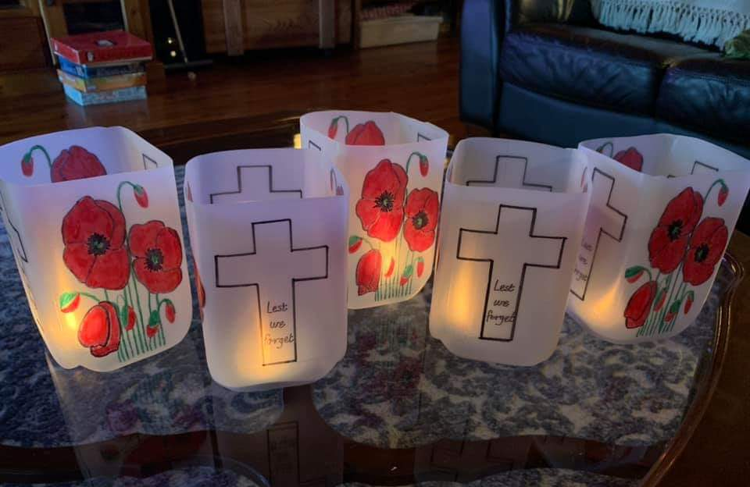
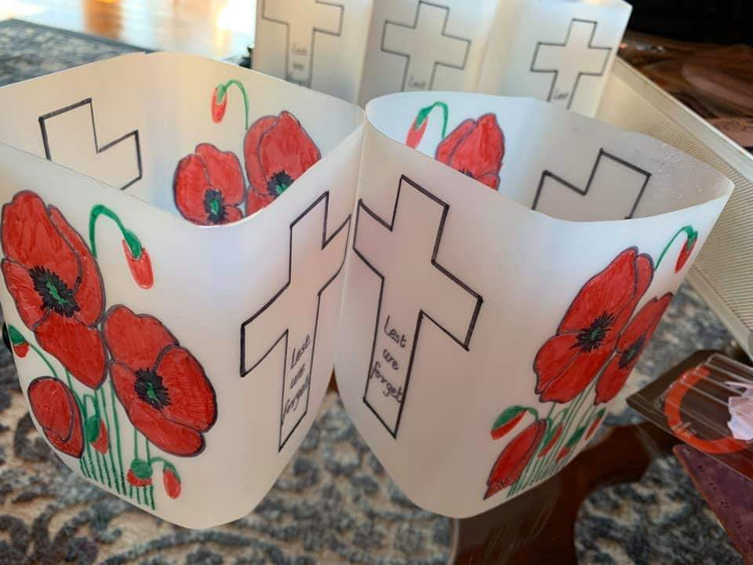
Make a Poppy Wreath & Poppy Lantern

Poppy Lantern

1 x 2L Plastic Milk Container (Top Cut Off)
Poppy Pictures (template on next page)
Coloured Pencils or Texta’s
Glue
Tealight Candle

Print out the Poppy Template on the next page or draw your poppies on the milk container.

Colour in your poppy picture

If you have printed out the template, cut around in and glue it onto the milk carton

Put your tealight candle in the bottom ready to light on ANZAC Day
Poppy Wreath:

1 x 1doz Egg Carton
Cardboard Ring
Red Paint
Black Paint or Black Texta
Flowers or Leaves from your garden (if you have any)
Glue
Paintbrush

Cut out each egg holder from the egg carton

Paint each egg holder with the red paint

When the red paint is dry, paint or colour the centre in black

Glue each “poppy” onto the cardboard ring making a wreath

If you have leaves or flowers from the garden, glue those in between the poppies.

Please use both the Poppy Wreath & The Poppy Lantern when participating in the ANZAC Driveway Dawn Service.

If anyone needs any equipment to complete these activities, please let us know. We should be able to get hold of 2L plastic milk containers, tea light candles and egg cartons and arrange a contactless drop off/pickup

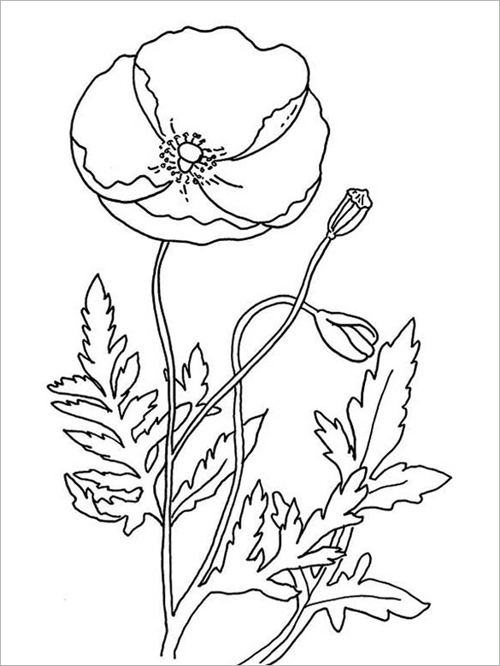

ANZAC Word Search

