Ideas for Venturer evenings

- Weekly themed photo challenge
- 1st April - Remote control
- ? – Cute Pet Photos
- ?

- Jamboree of the Internet – 3rd to 5th of April
Join the JOTI - https://www.jotajoti.info/

- Fancy Dress evening
Everyone dresses up in a cool outfit or hat
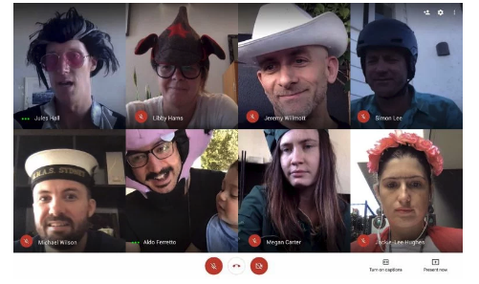

- Make a weird / cool video and share with the group
Use tiktok or other platform to create a video around a specific theme

- Murder Mystery evening – eg. https://www.mymysteryparty.com/zombie-escape-a-mystery-game/

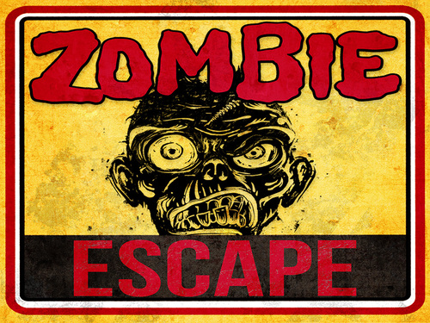

- Trivia / Riddles / puzzle evening
eg. - https://www.paulsquiz.com/free-quiz-questions/complete-pub-quizzes

- Camp at home
Create a campsite / fort in your house / garden – give the unit a virtual tour at the meeting

- Cooking challenge
Everyone makes damper, johhny cakes and apple turn over
Johhny Cakes. Make dough out of flour and water roll into round flat pieces and fry . Eat with jam and cream, Turnovers. Make as before fill with stewed apples & jam, fold dough over and cook in oven .
I have tried all these at camps.

- Virtual sailing regatta
eg - http://virtualregatta.com/

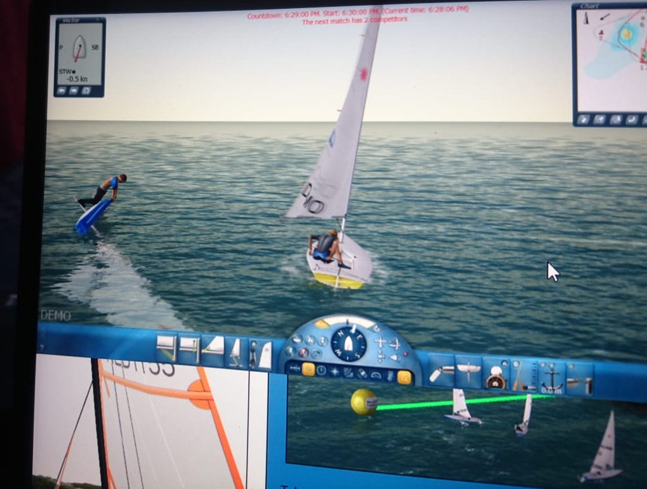

- Musical instrument / band session
Everyone plays a musical item for the unit
We try and play a simple song together, with everyone jamming

- Understanding Fossil’s Rover
Fossil provides a tour of his Rover – how it works, how to drive it

- Best at home sailing recreation
Build your best sailing simulator, and take a video of you sailing in it

- Create a Rube Goldberg machine in your home / back yard and video it
Some ideas and mechanics - https://www.youtube.com/watch?v=MgDF1tyoOvU
Inspiration videos - https://www.youtube.com/results?search_query=basic+rube+goldberg+machine
Good inspirations - https://www.youtube.com/watch?v=qybUFnY7Y8w
https://www.youtube.com/watch?v=dsZP0iSWj_A (Joseph’s machines)

9. Home treasure hunt / scavenger hunt
Organiser shares a list, everyone has 20 minutes to find as many of the items as possible

- Semaphore Challenge
– 2 teams have to send a message in semaphore, 2 teams have to interpret it.

- Interesting sailing knots
Learn how to do a monkey’s fist, whippings, and other knots – everyone finds rope they can use for the evening
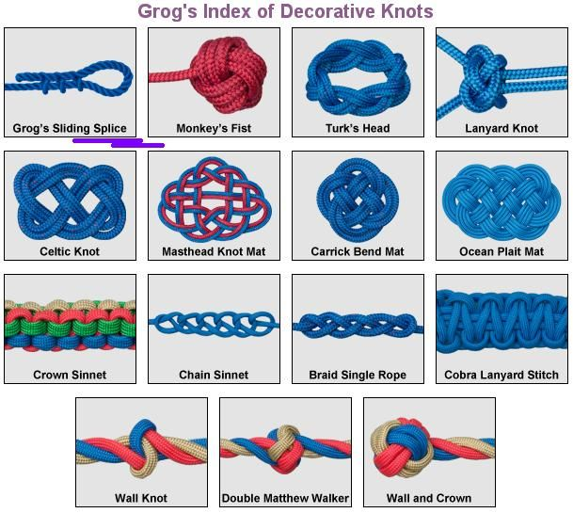

- Create / find a dance and teach it to the unit, so the unit can Zoom dance to it
https://www.linkedin.com/feed/update/urn:li:activity:6650565673162547200/

- Baby photo competition – everyone sends a baby photo to the organizer – then have to work out who is who

- Design a Unit t-shirt – everyone designs a unit shirt, either individually or using online collaboration tools. Unit votes on which one gets made

